- Create one VPC in N. Virginia region.
Got to vpc create vpcnamecidr
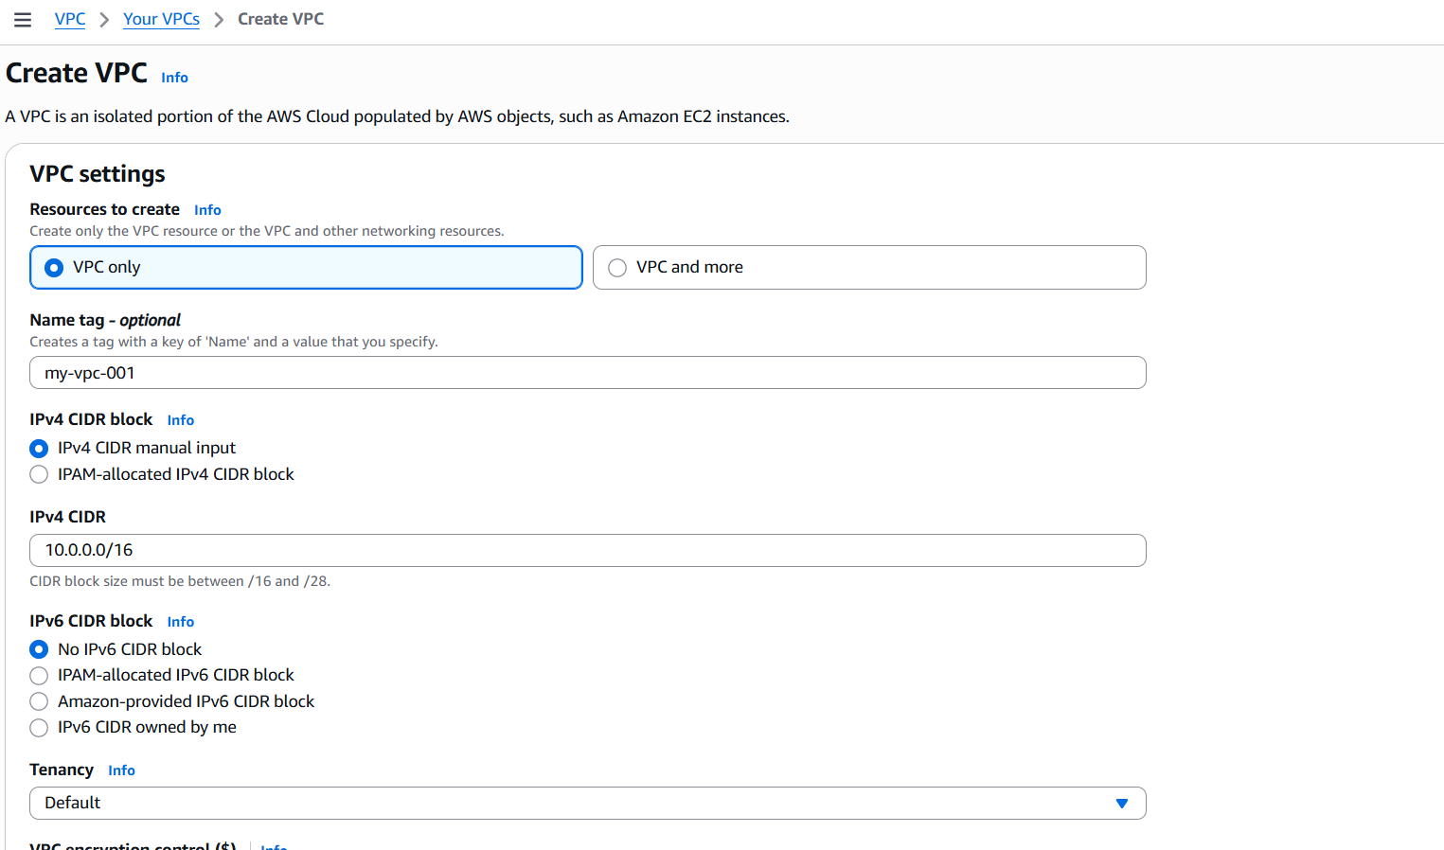
Click on create and vpc are created
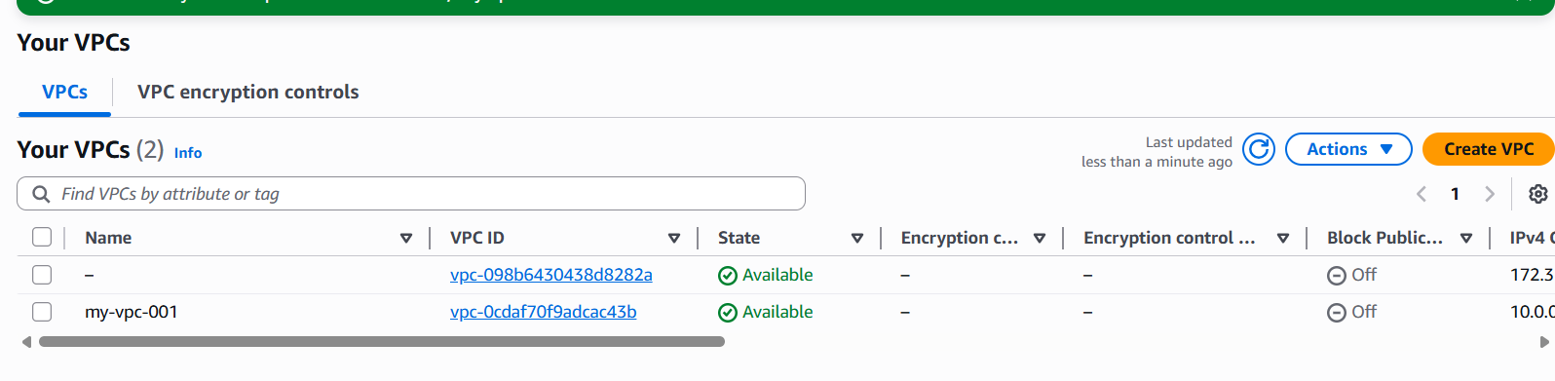
- Create two subnets: one public subnet and one private subnet.
Go to subnets create subnetnameavailavility zoneipv4 vpc cidr block click on create
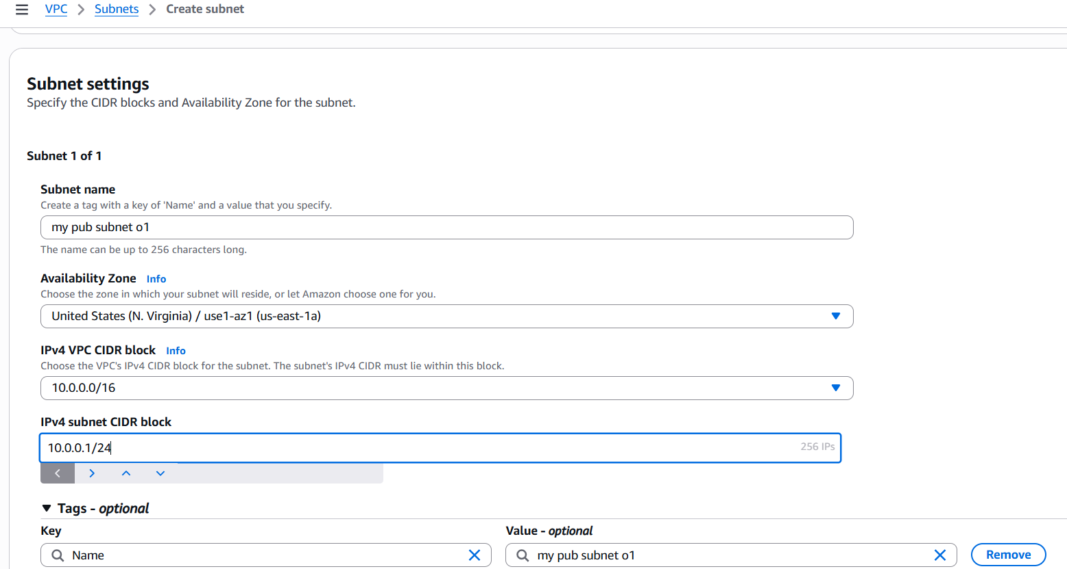
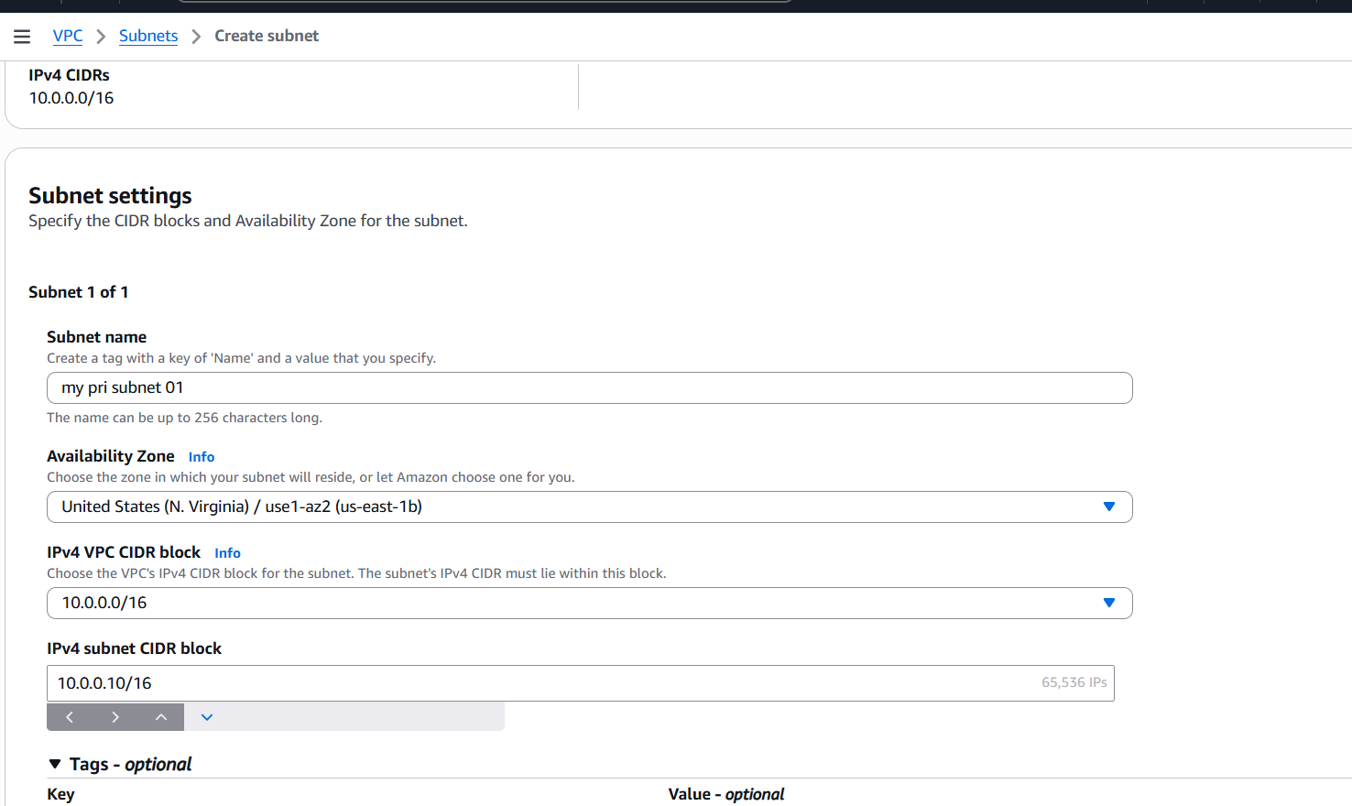
Finally created the public and private subnets
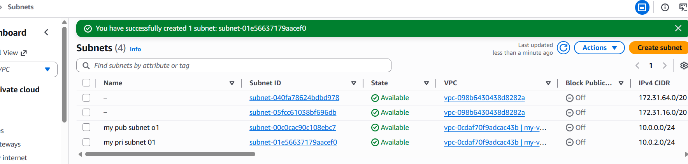
- Attach an IGW to the VPC.
Go to internet getewaycreate igwand attach vpc
Go to actions attach to vpc
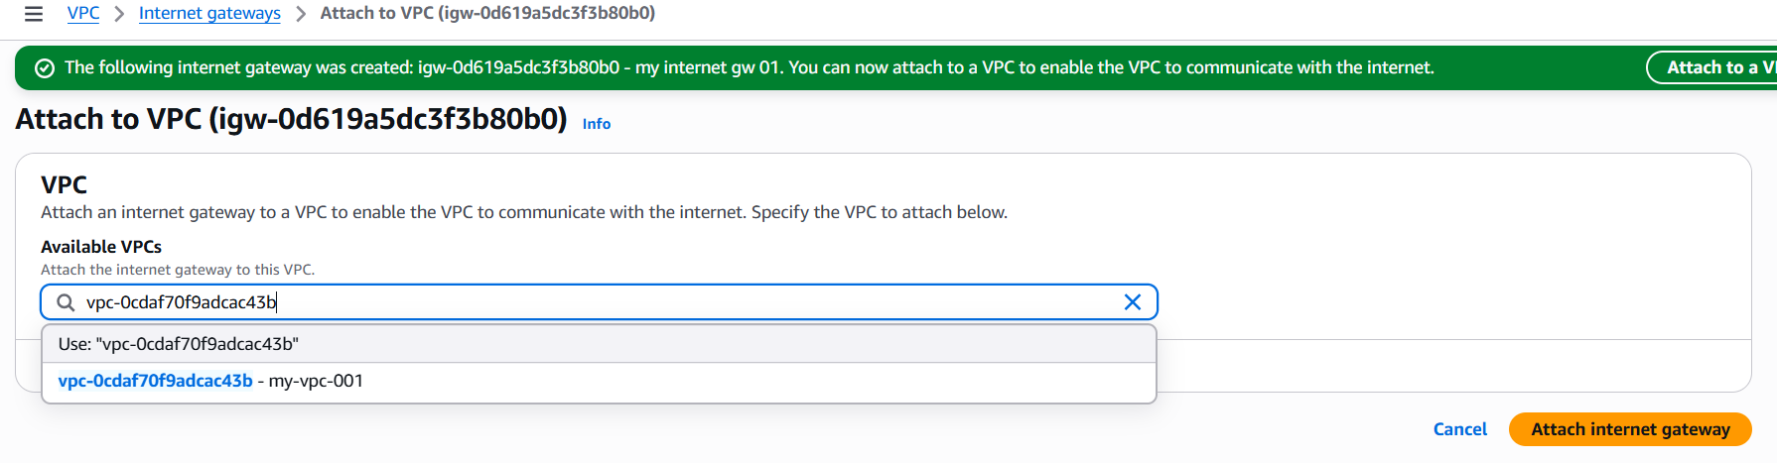
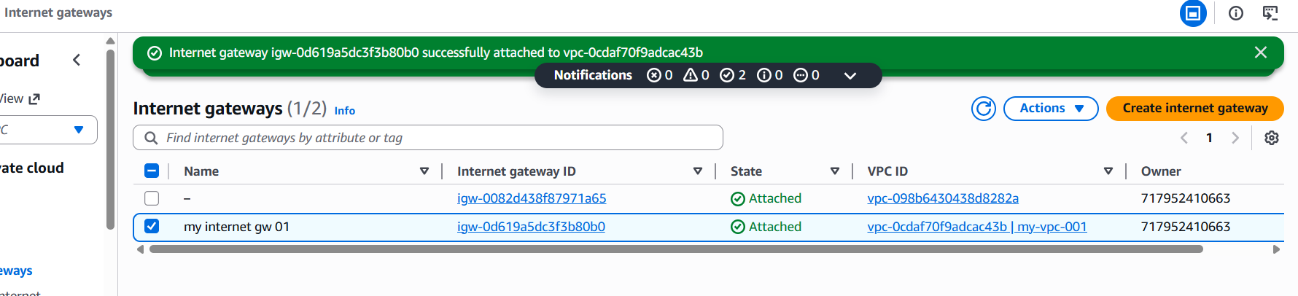
- Create one public route table (RT) and one private route table.
Go to route table create one public and private route tables
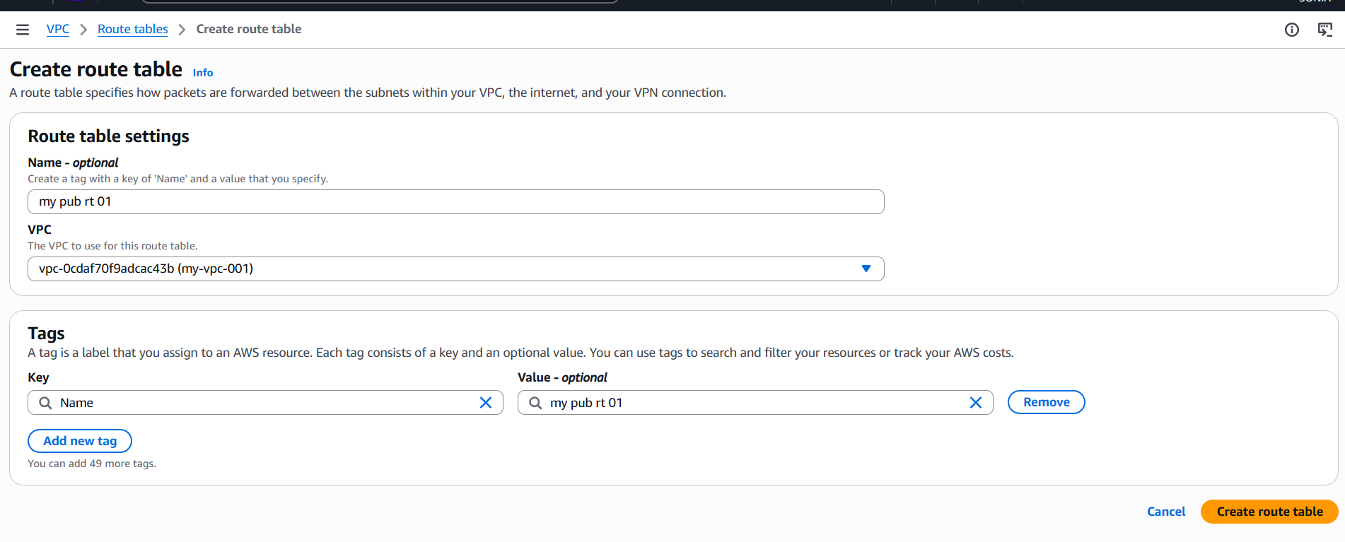
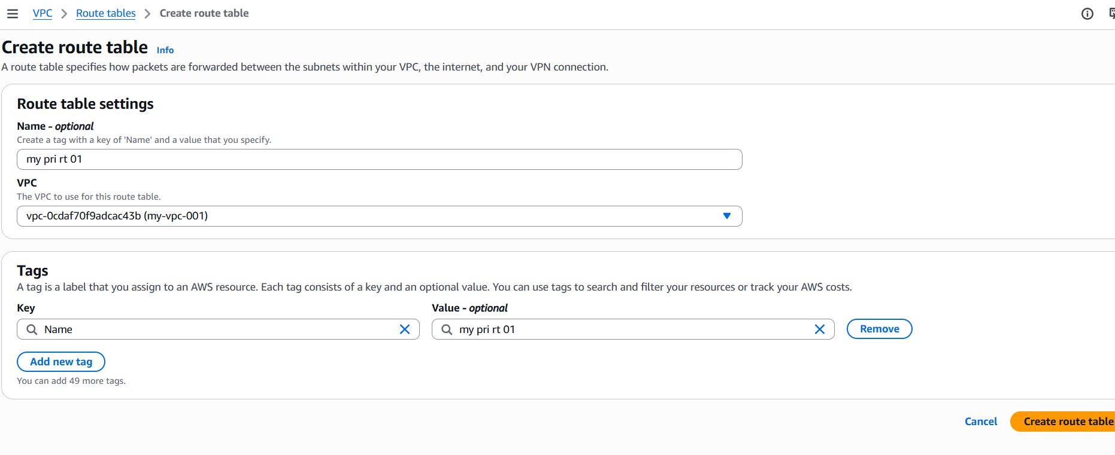
Created public and private route tables
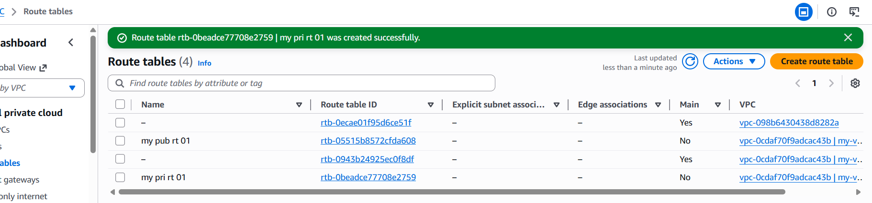
Then select public rt go to route edit route add internet gateway
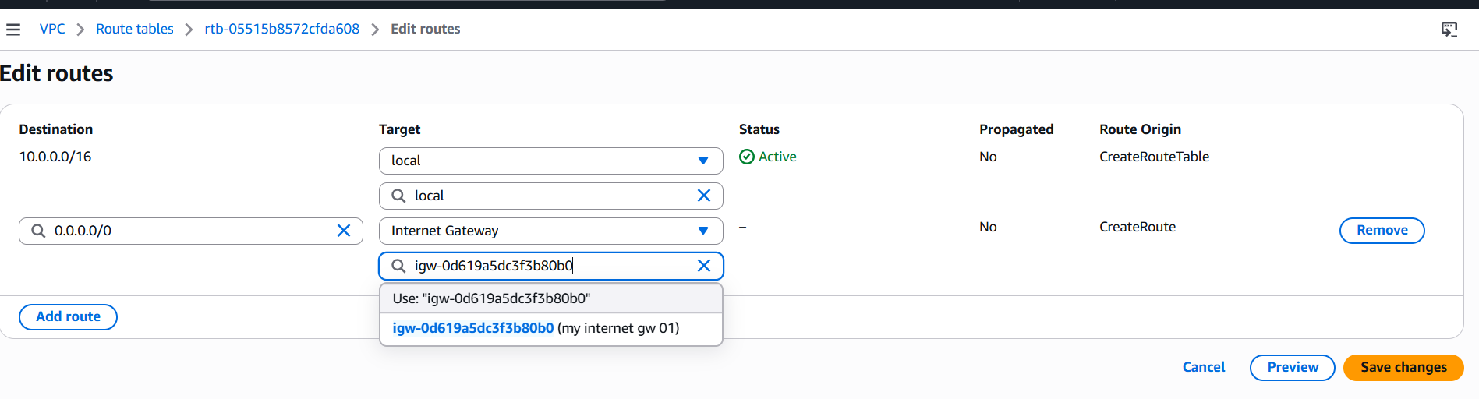
- Deploy a NAT gateway in the public subnet and attach the NAT gateway to the private subnet.
Go to nat gateway create nat gatewayand go to route table select private RTedit routesadd routesave changes
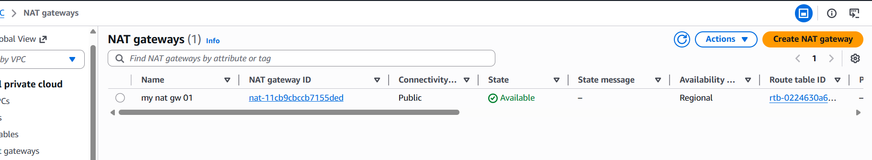

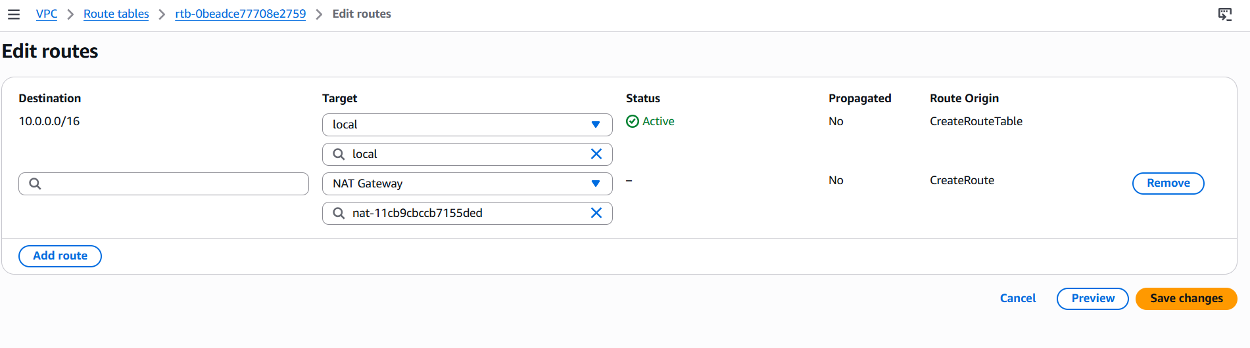

- Create two instances, one in the public subnet and one in the private subnet.
Go to ec2 launch one pub instanceone private instance
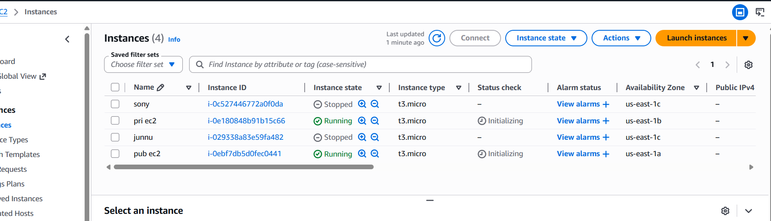
- Deploy Apache server on both EC2 instances with a sample index.html file.
Goto gitbash --> connect public instance-->

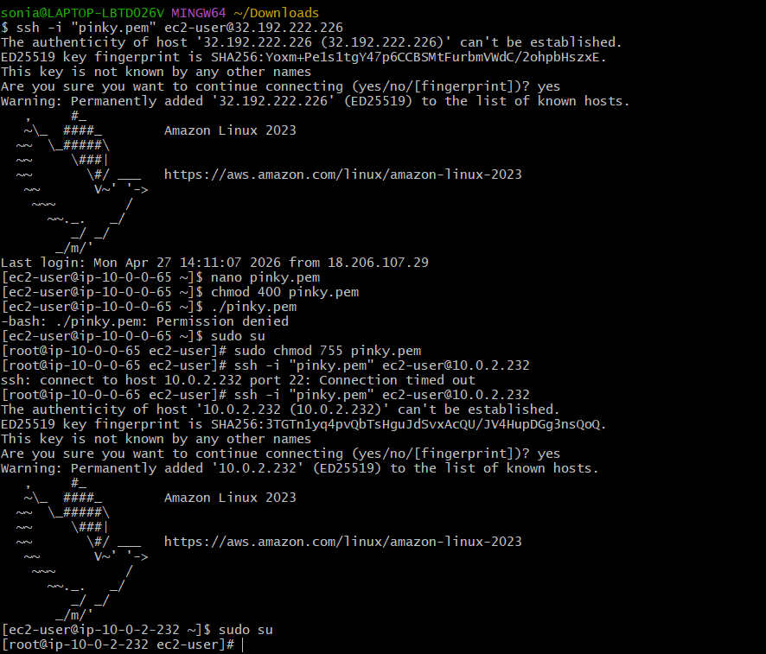
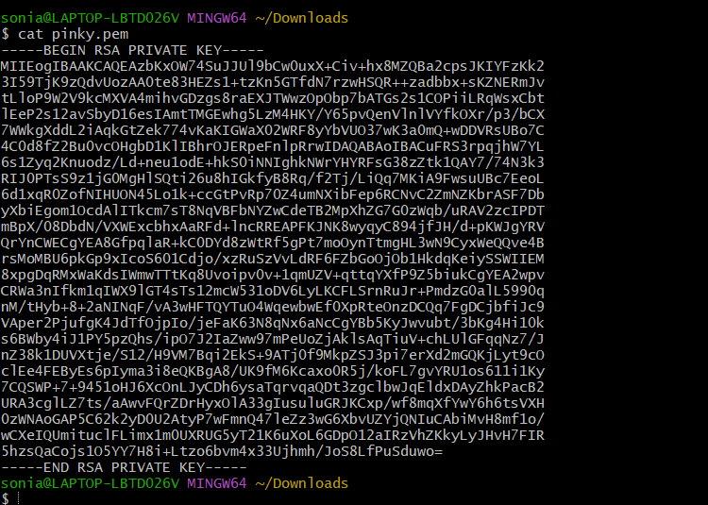
First we install httpd privete instance
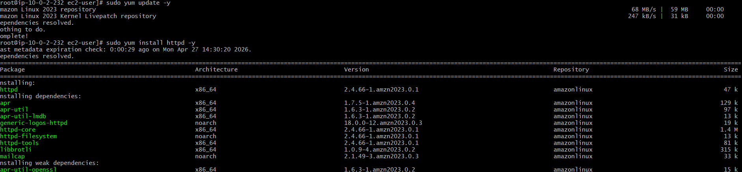
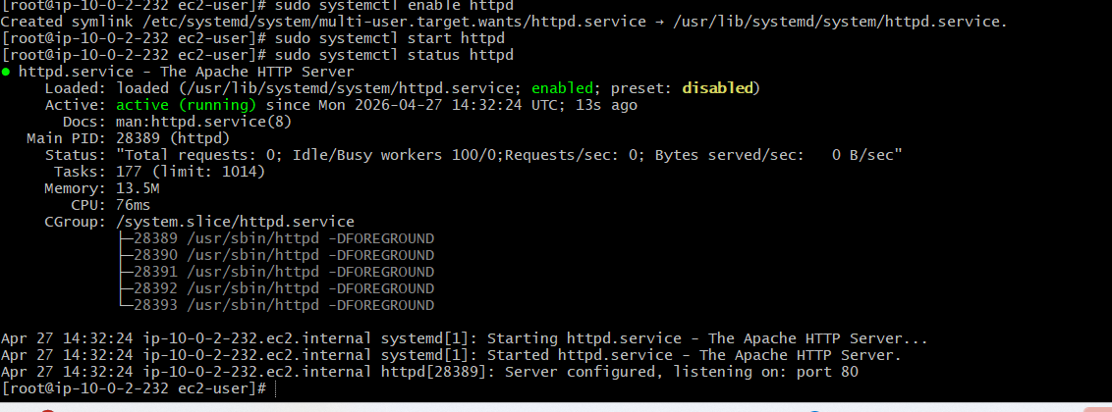
Install public instance
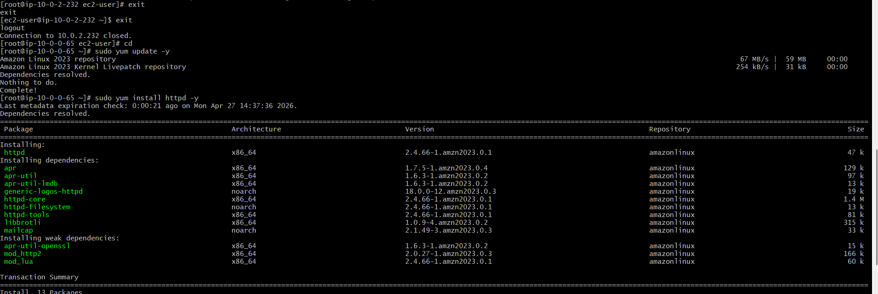
Deploy the index.html file
Sudo vi /var/www/html/index.html
Write script
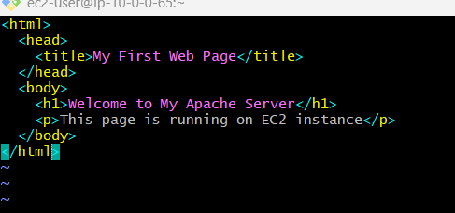
Copy the public ip go to the browser check the appilication
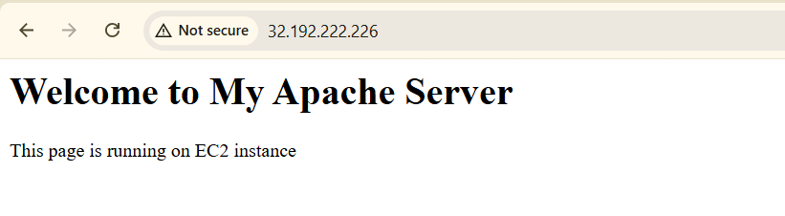

- Create one application load balancer and attach it to both EC2 instances.
.

Go to Load Balancer Service
- Open AWS EC2 Console
- In left menu → Load Balancers
- Click Create Load Balancer
- Choose Application Load Balancer

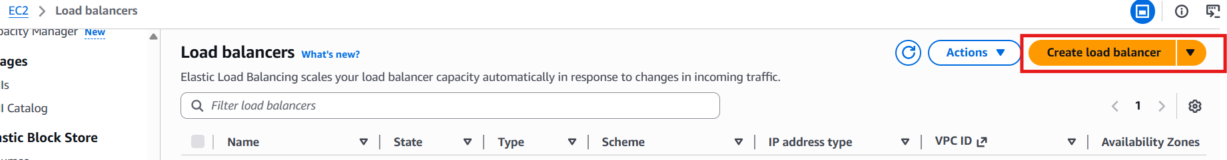
- Name: My-ALB
- Scheme: Internet-facing
- IP type: IPv4

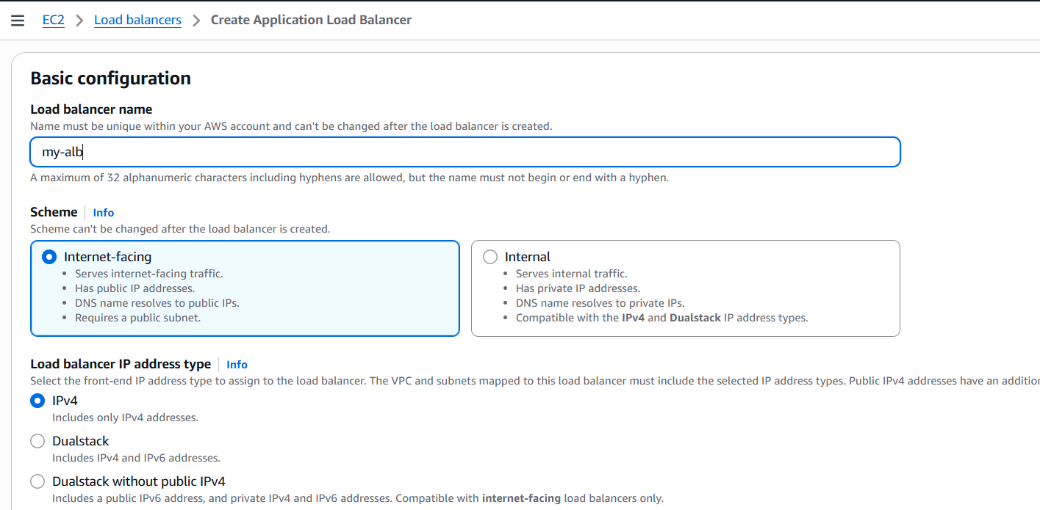
- VPC: Select your VPC
- Availability Zones:
- Select 2 public subnets 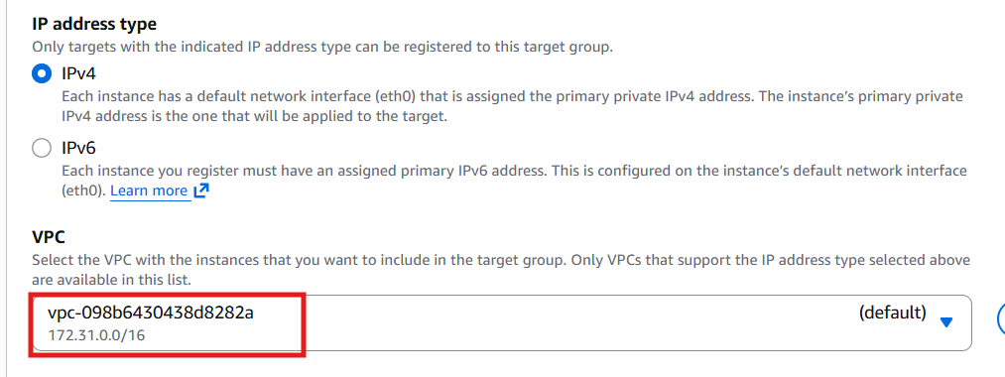
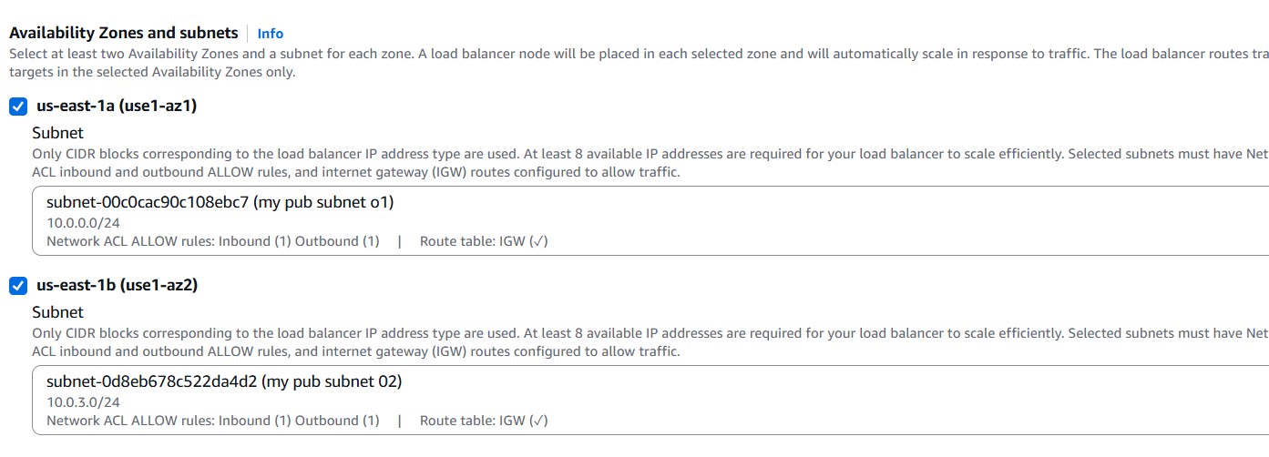
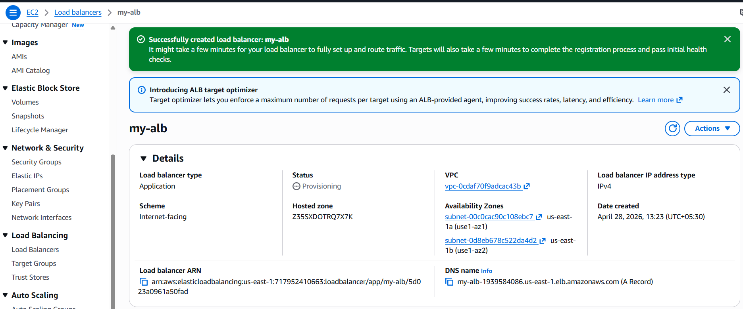
• Click Create Target Group
• Target type: Instances (we connect ec2)
• Name: My-Target-Group
• Protocol: HTTP
• Port: 80
• VPC: Same VPC

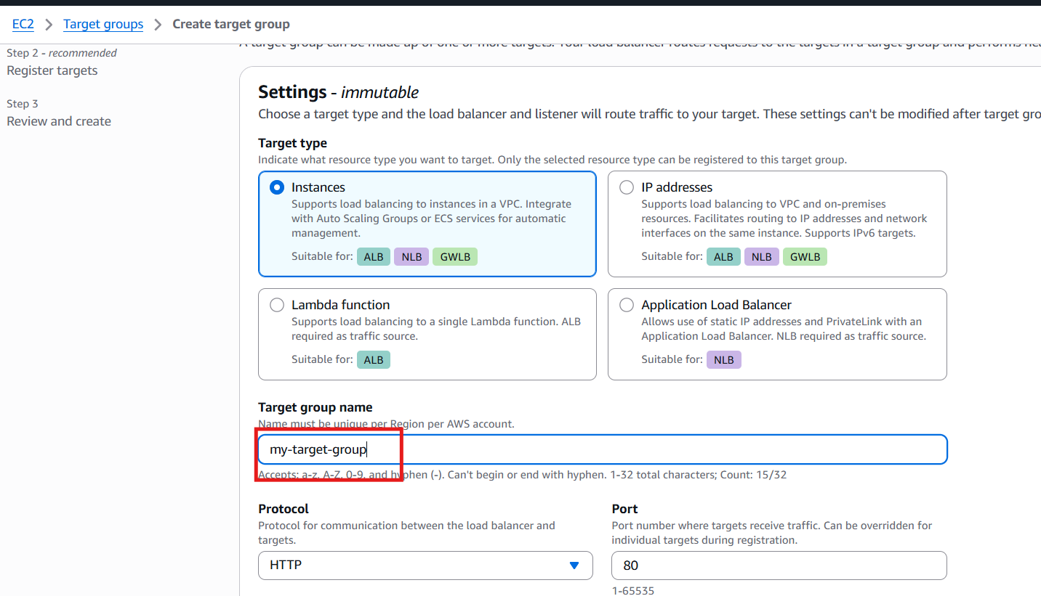
• Public EC2 instance
- Private EC2 instance
• Click Include as pending below
• Click Create Target Group

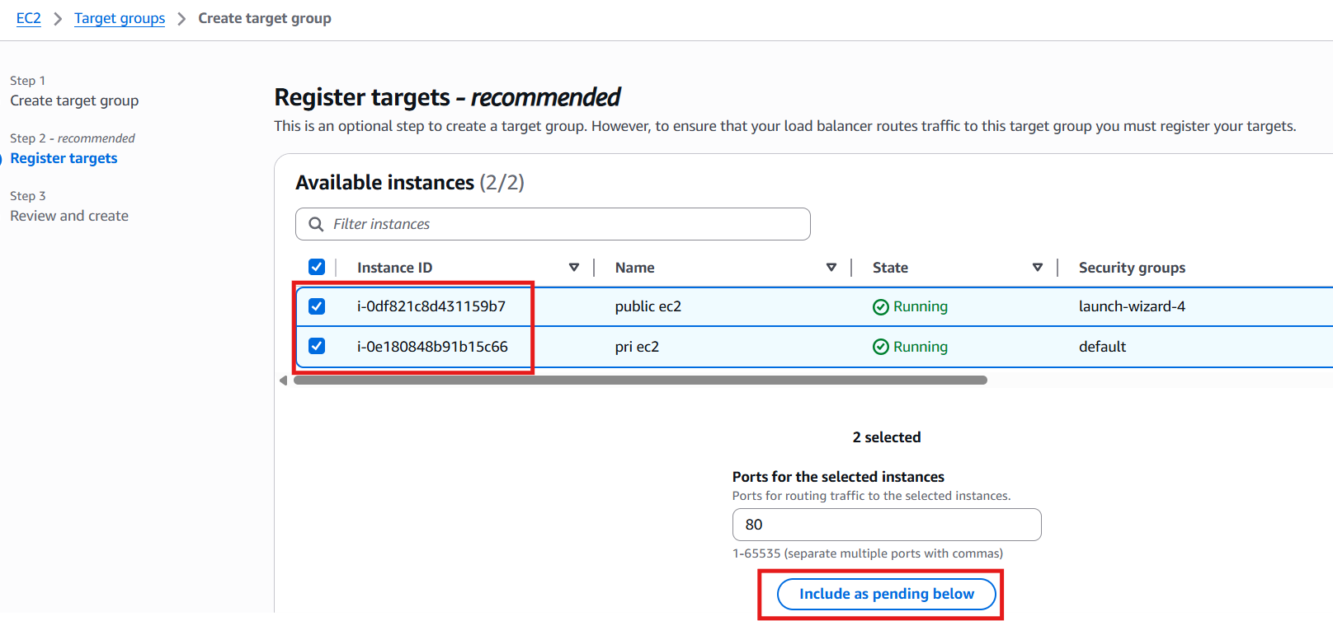
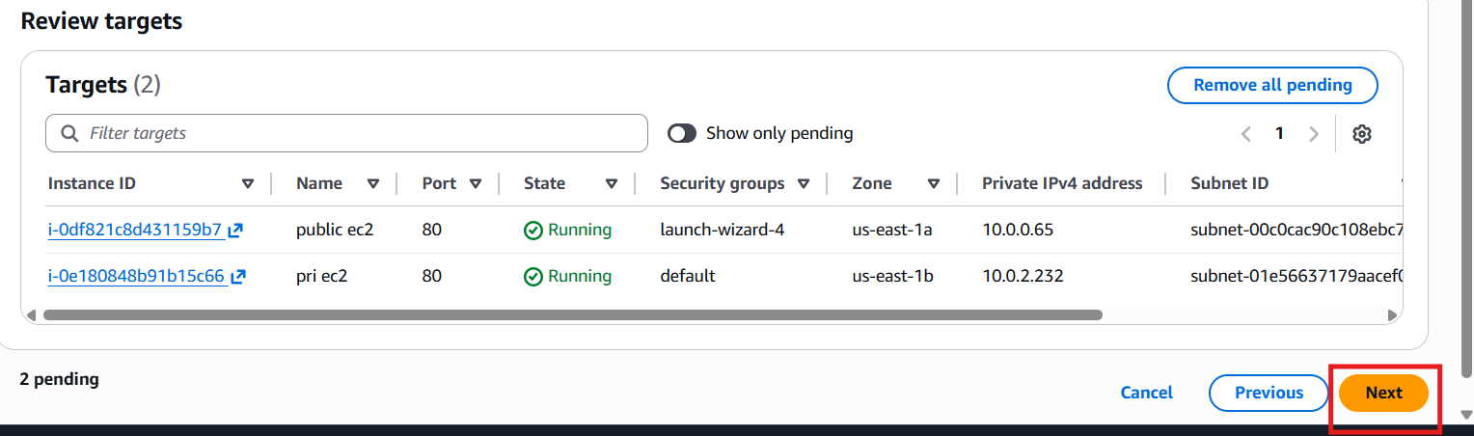
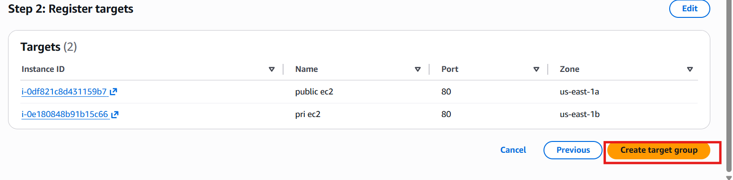
- Go back to ALB creation
- Select your Target Group
- Click Create Load Balancer

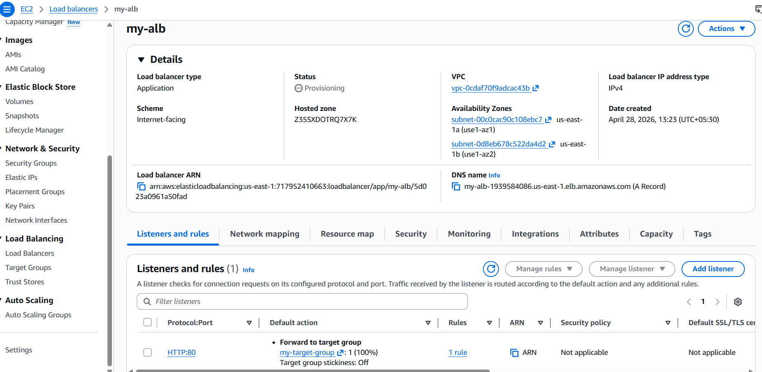

- Store application load balancer logs in s3
Go to Amazon S3
- Click Create bucket
- Bucket name: my-alb-logs-bucket
- Region: same as ALB
- Keep defaults → Click Create

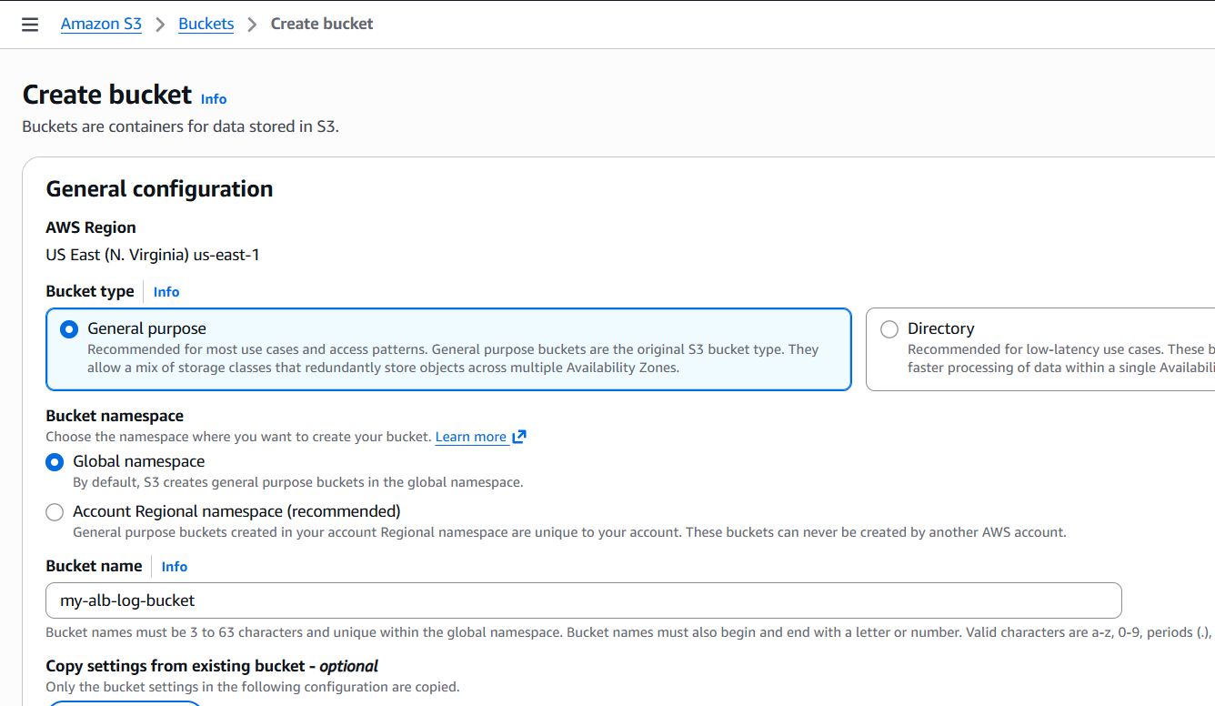
successfully created s3 bucket
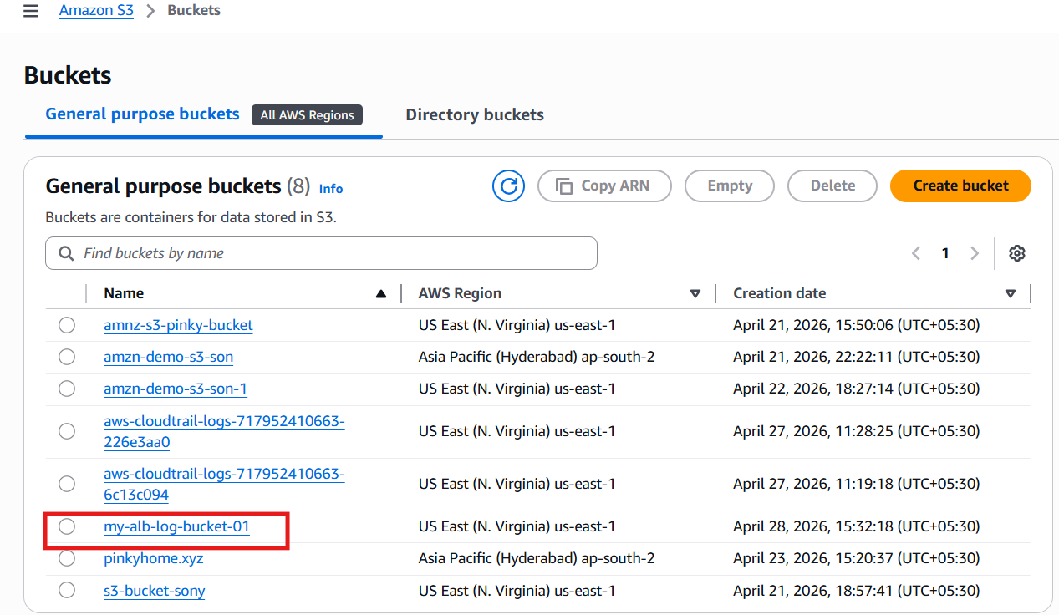

Your ALB needs permission to write logs into S3.
Go to:
- Bucket → Permissions → Bucket Policy
- Paste this (edit region & account ID)
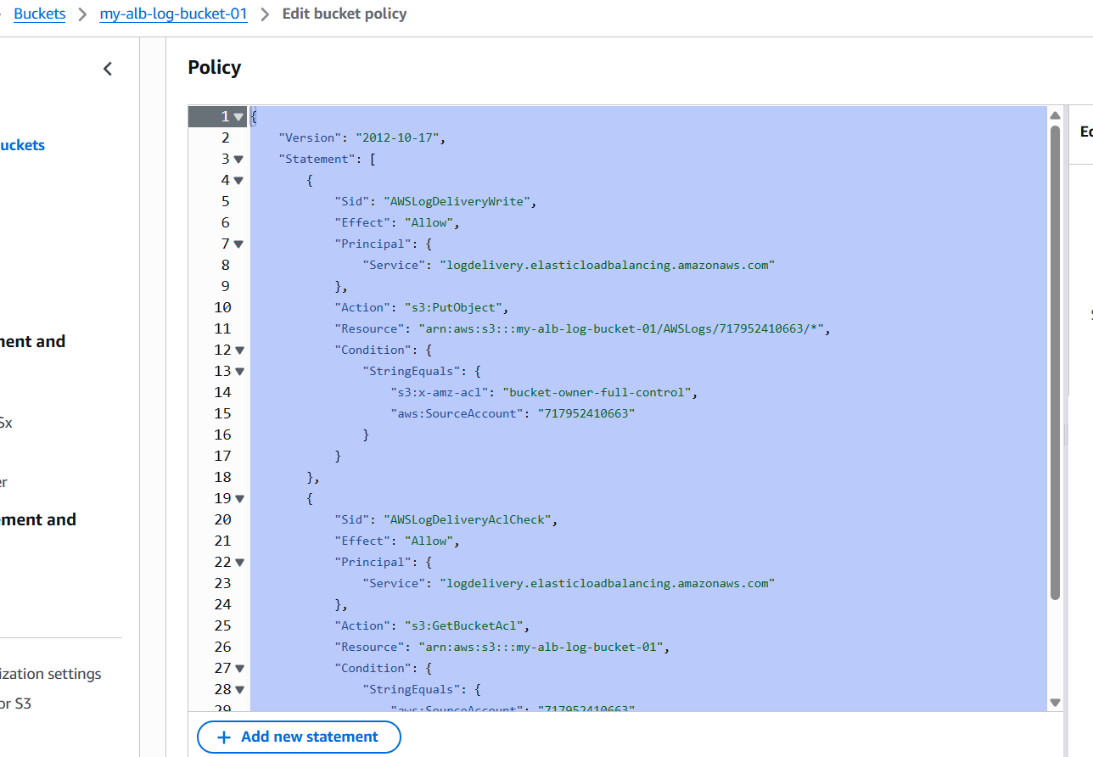
Go to AWS EC2 Console
- EC2 → Load Balancers
- Select our Application Load Balancer
- Go to Attributes tab
- Click Edit
Enable:
- Access logs → ON
- Choose our S3 bucket → my-alb-logs-bucket

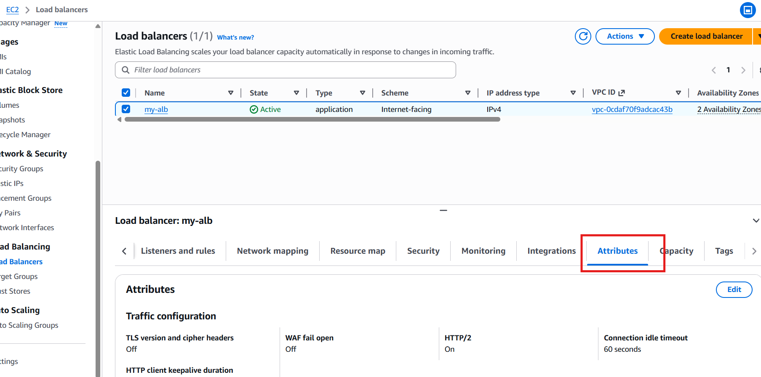
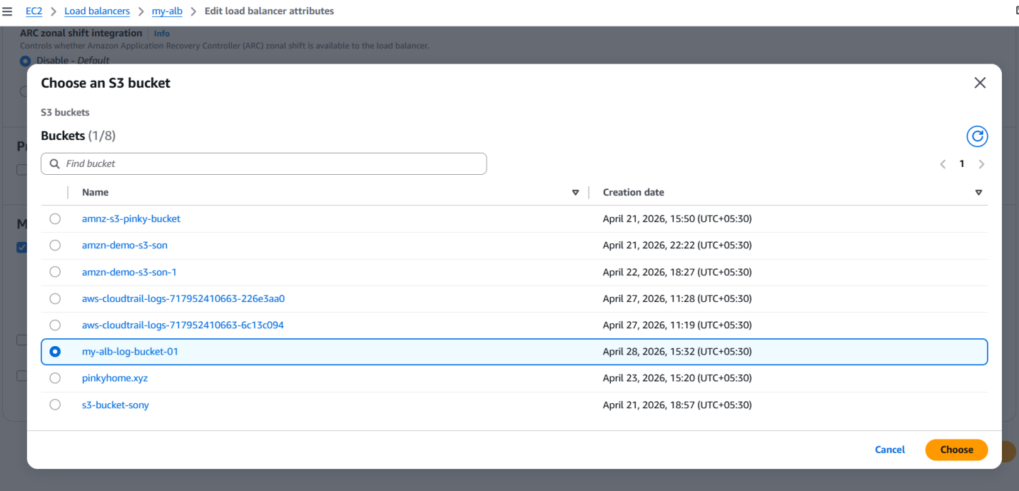
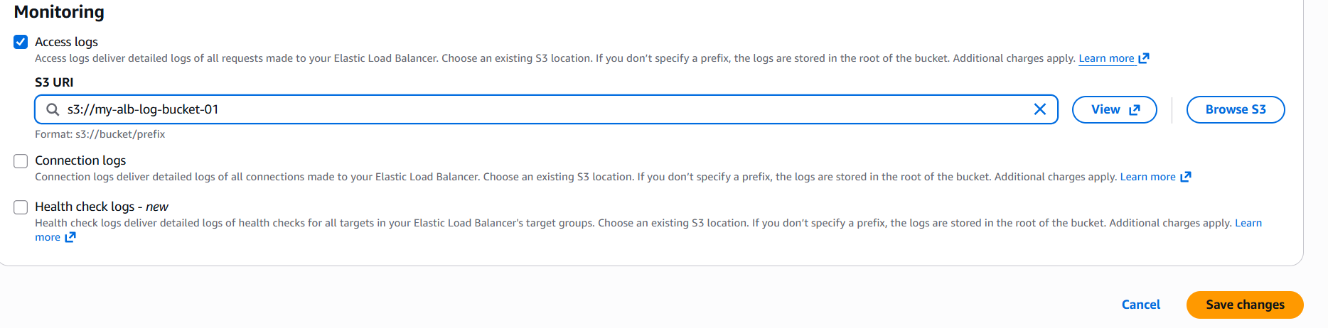
Save changes
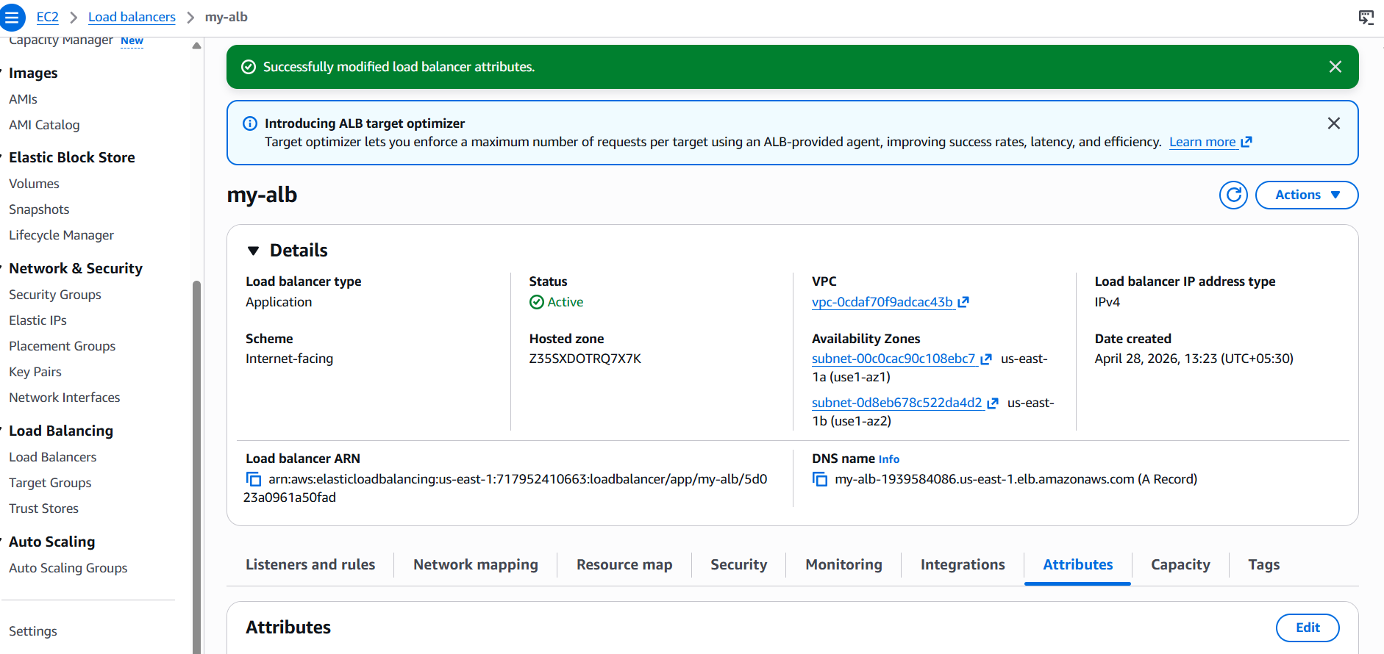
- Store the VPC flow logs in a CloudWatch log group.
Go to Amazon CloudWatch Console
- Click Logs →log management--> Log groups
- Click Create log group
- Name: vpc-flow-logs
- Click Create
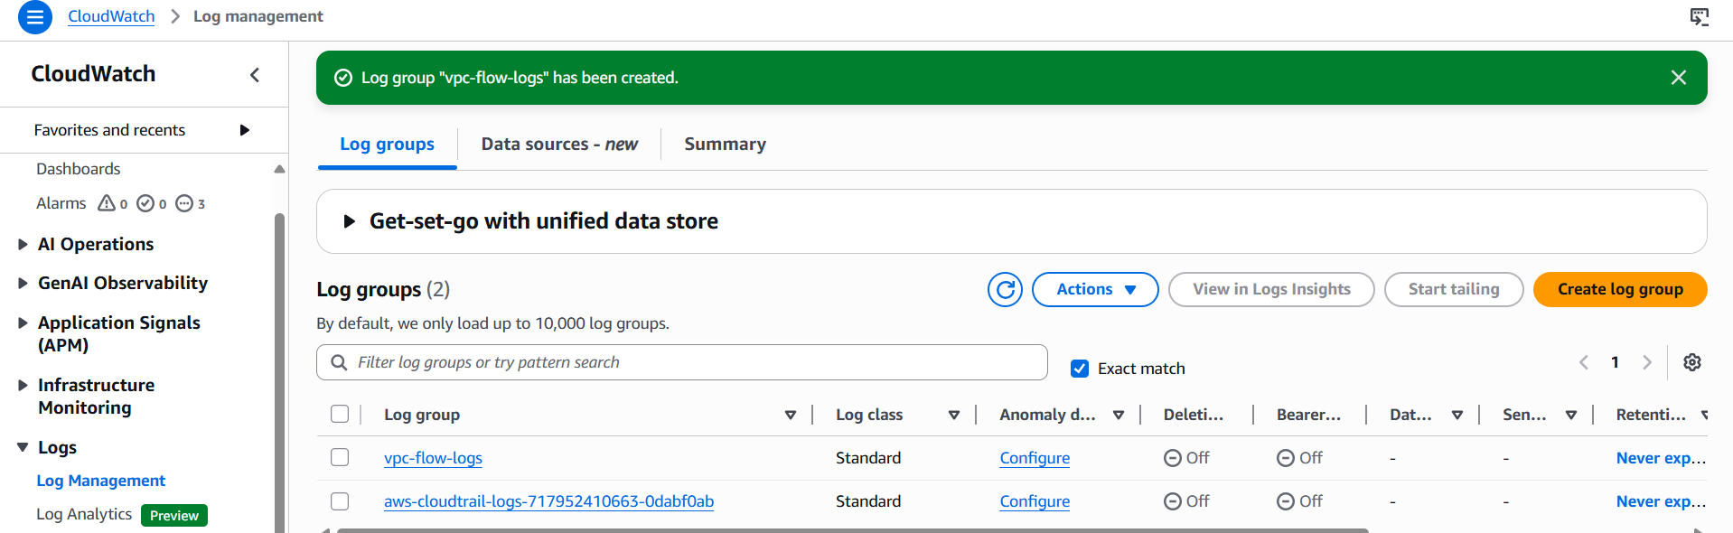
Go to AWS IAM Console
- Click Roles → Create role
- Trusted entity: AWS service
- Use case: ec2

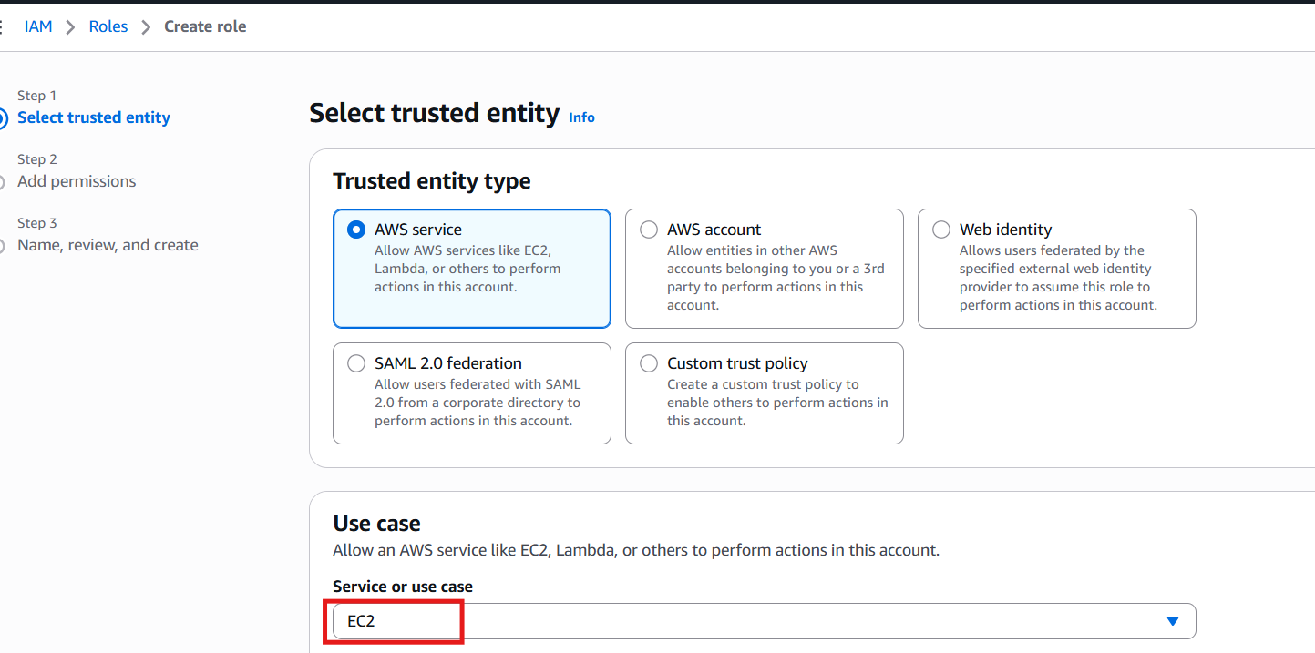
Add permissions -->cloudwatchfullaccess
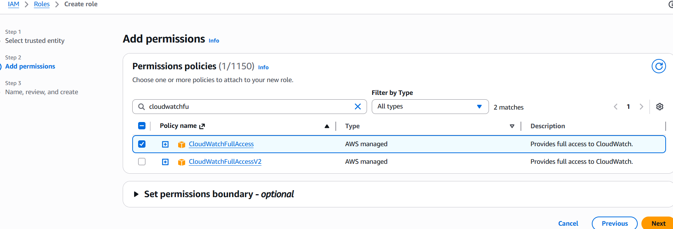
Create name-->then click on create
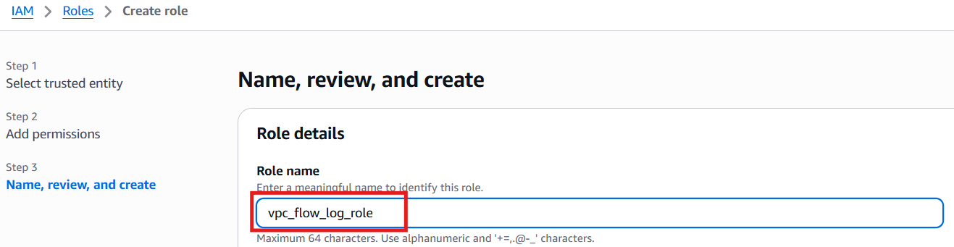
Created iam role successful
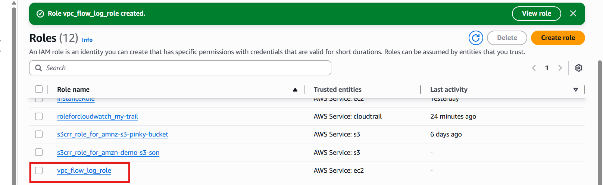
Go to AWS VPC Console
- Click Your VPCs
- Select our VPC
- Click Flow logs tab
- Click Create flow log

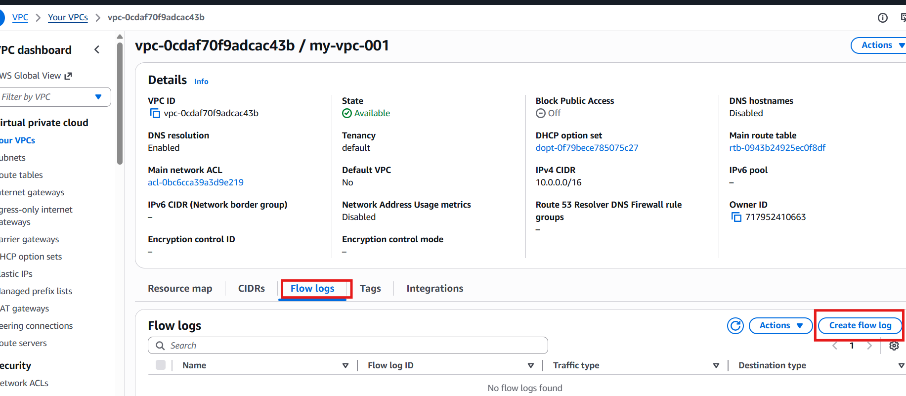
Give name-->minimum time-->choose destination-->send to cloudwatch logs-->add role-->then create vpc flowlogs
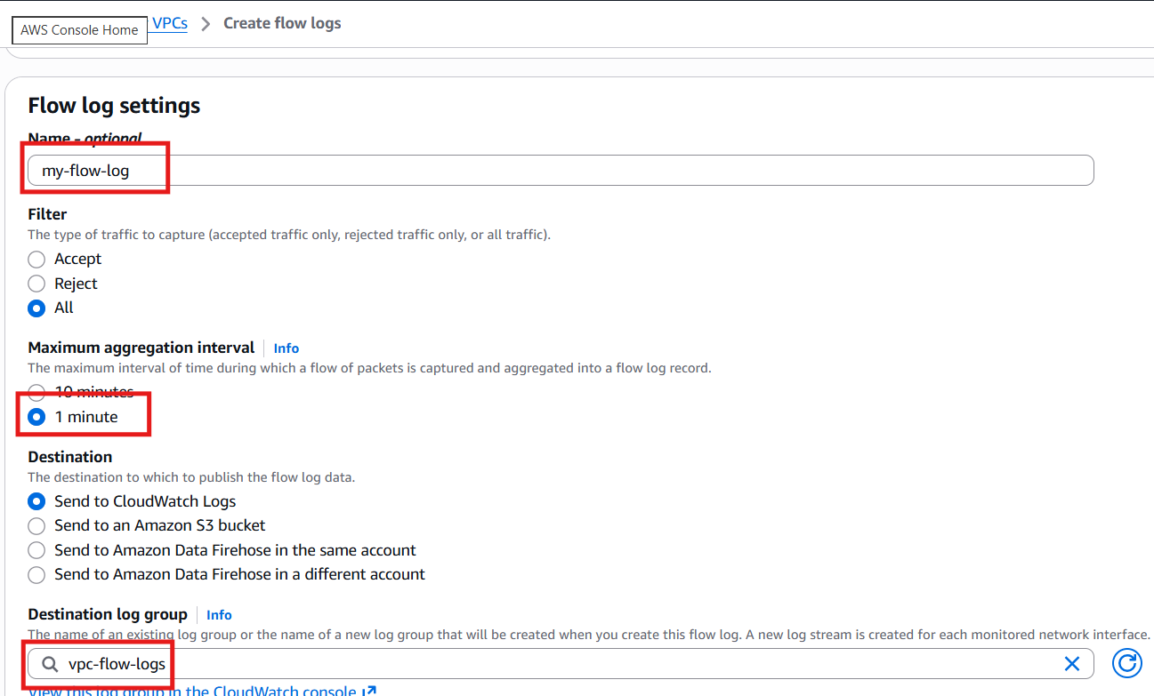
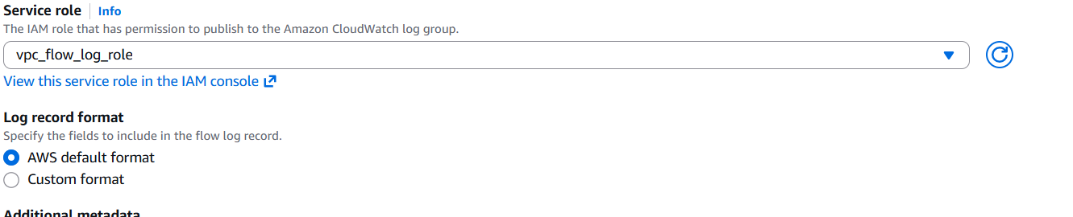

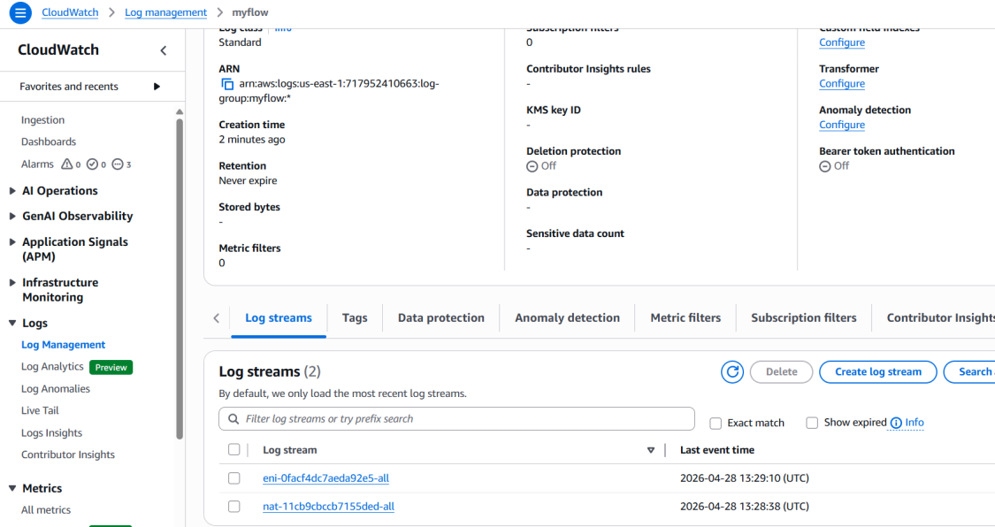

- Create monitoring dashboards to monitor CPU utilization and to monitor the Apache service.

Go to cloudwatch
Open Amazon CloudWatch Console
Dashboards → Create dashboard
- Name: EC2-Monitoring-Dashboard

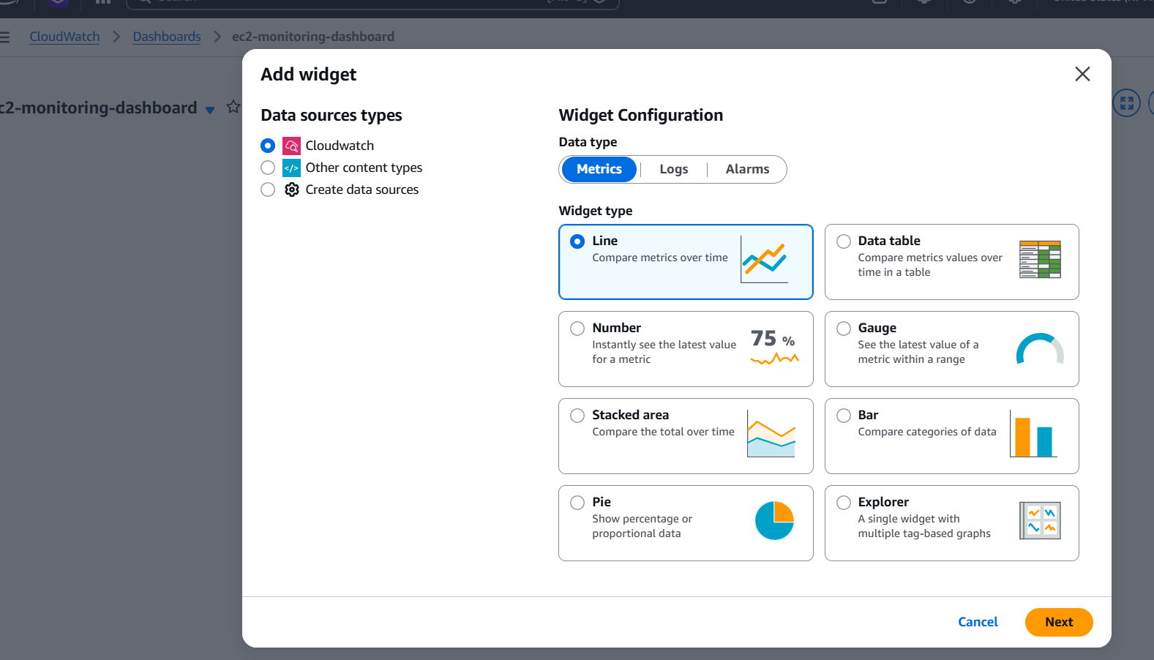
Go to metrics --> select EC2 --> per-instance metrics -->select cpuutilization
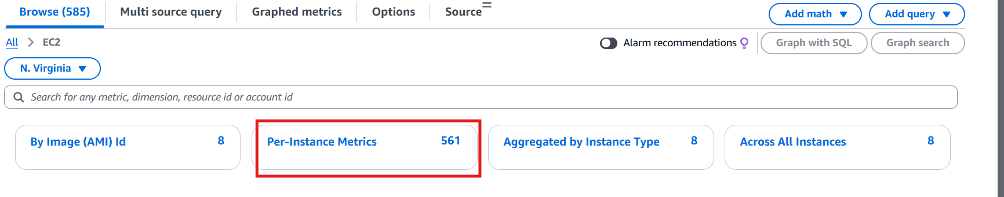

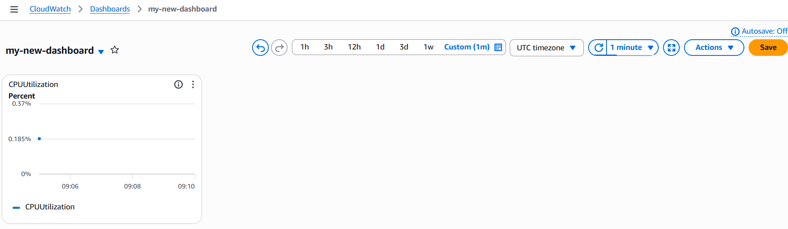
Go to ec2 login to our ssh
Install httpd

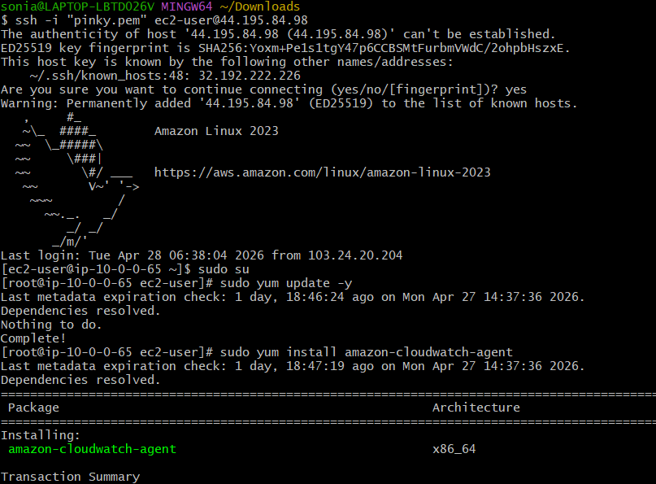
Create apache monitoring script
Give permissions
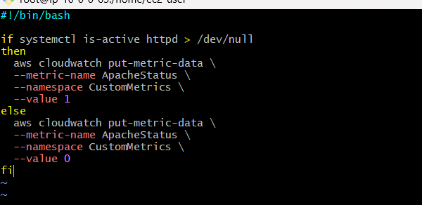
Connect the aws configure through cli
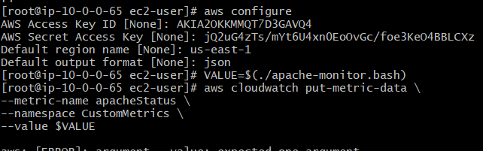
Go to cloudwatch -->click metrics-->open custom metrics-->select apache status-->
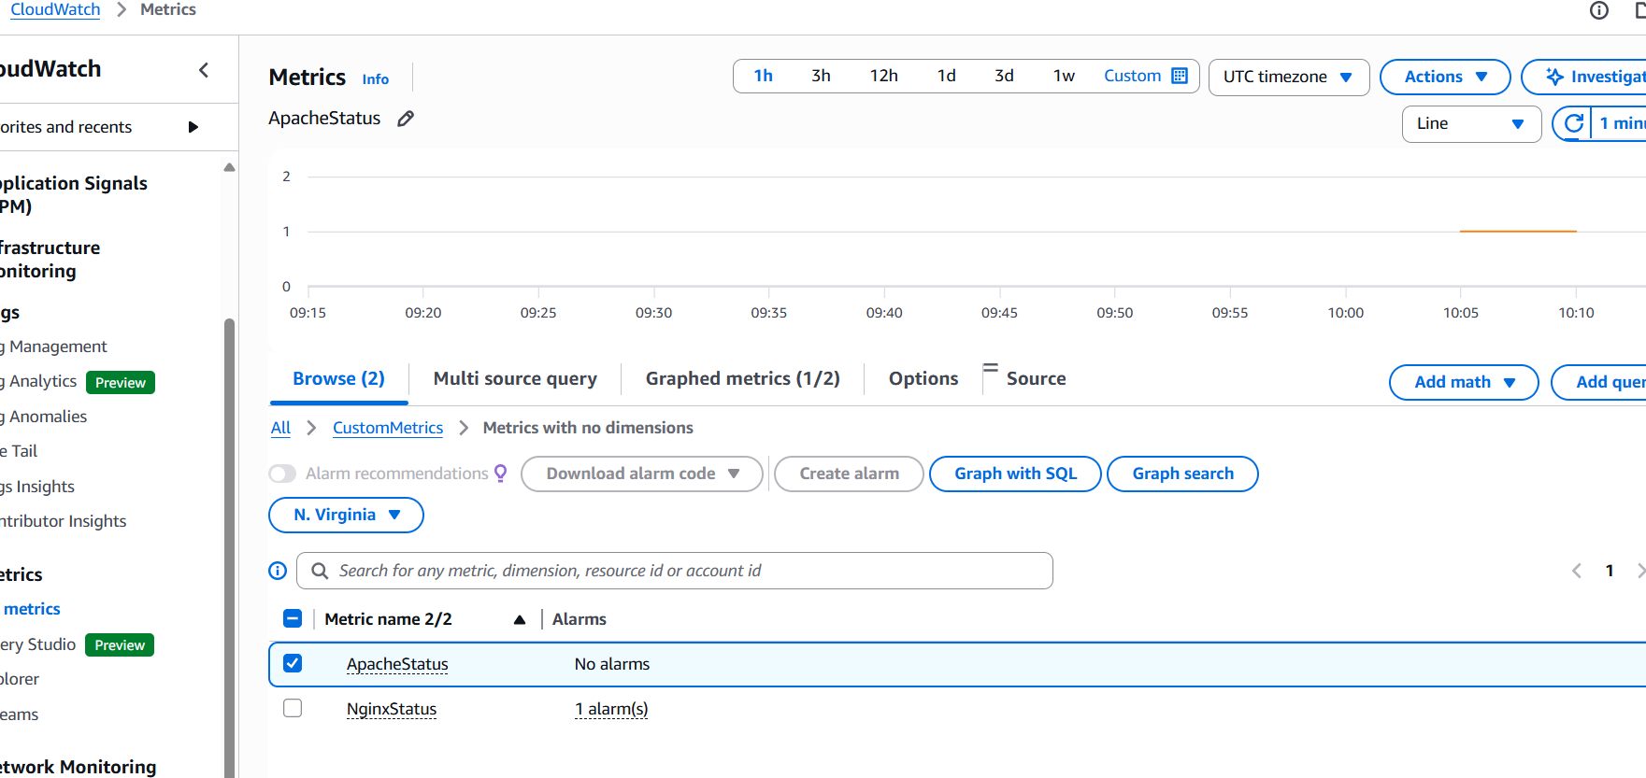
Go to create alarm-->select metric-->threshold type and valu-->setup alarm configure-->click on create
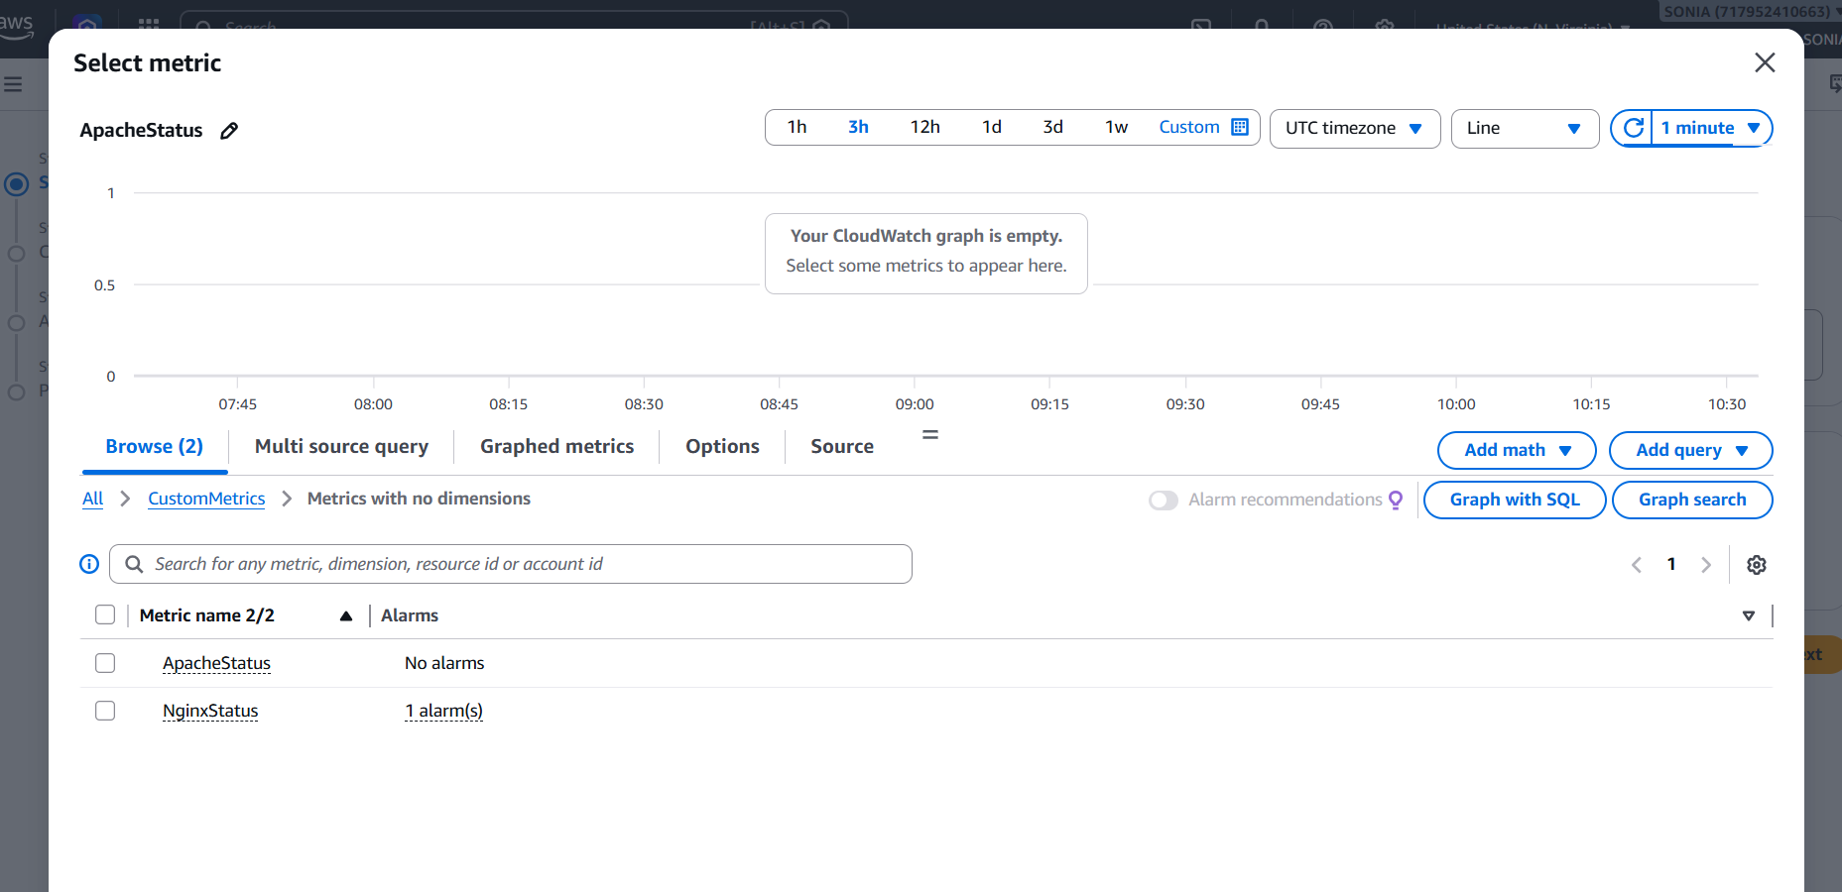
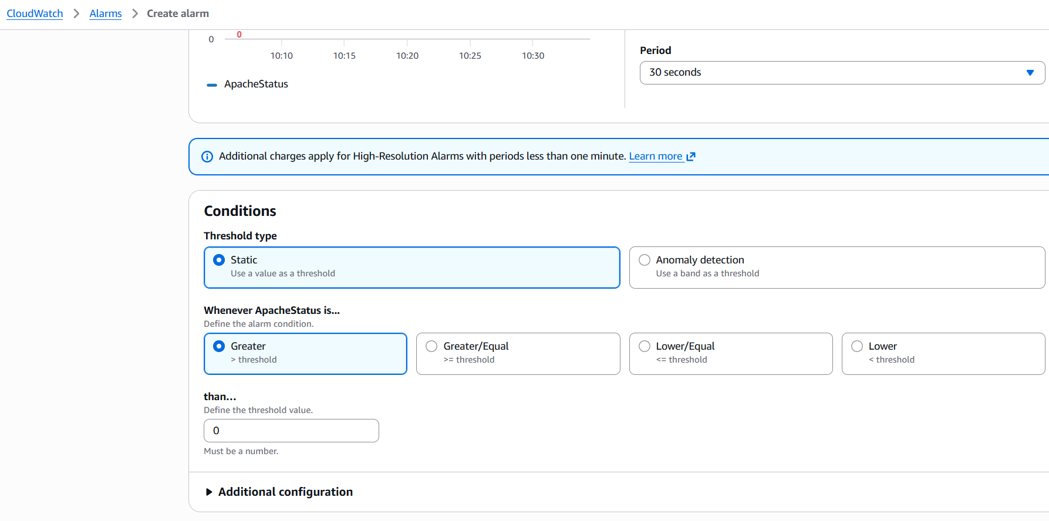
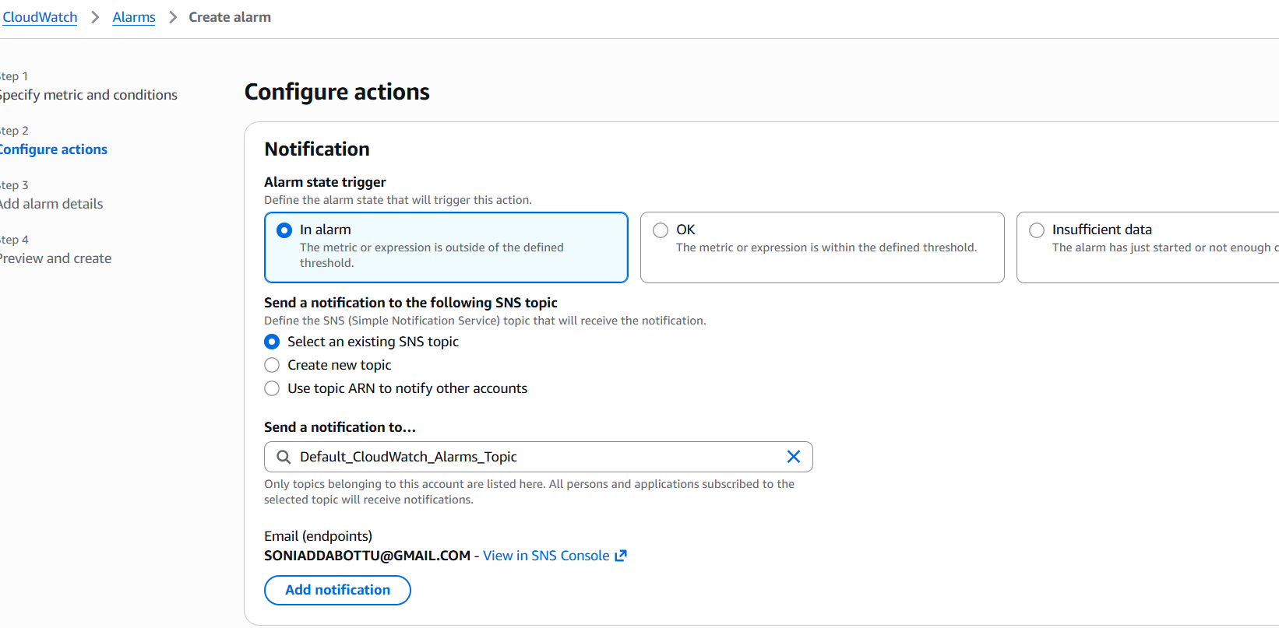
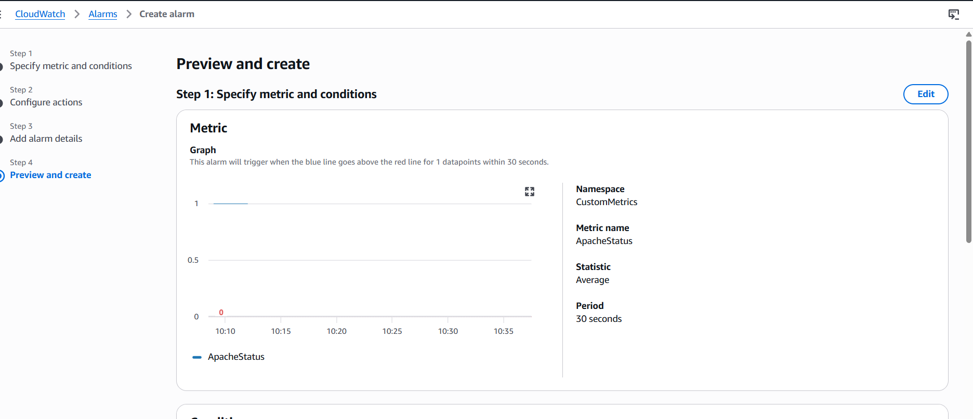
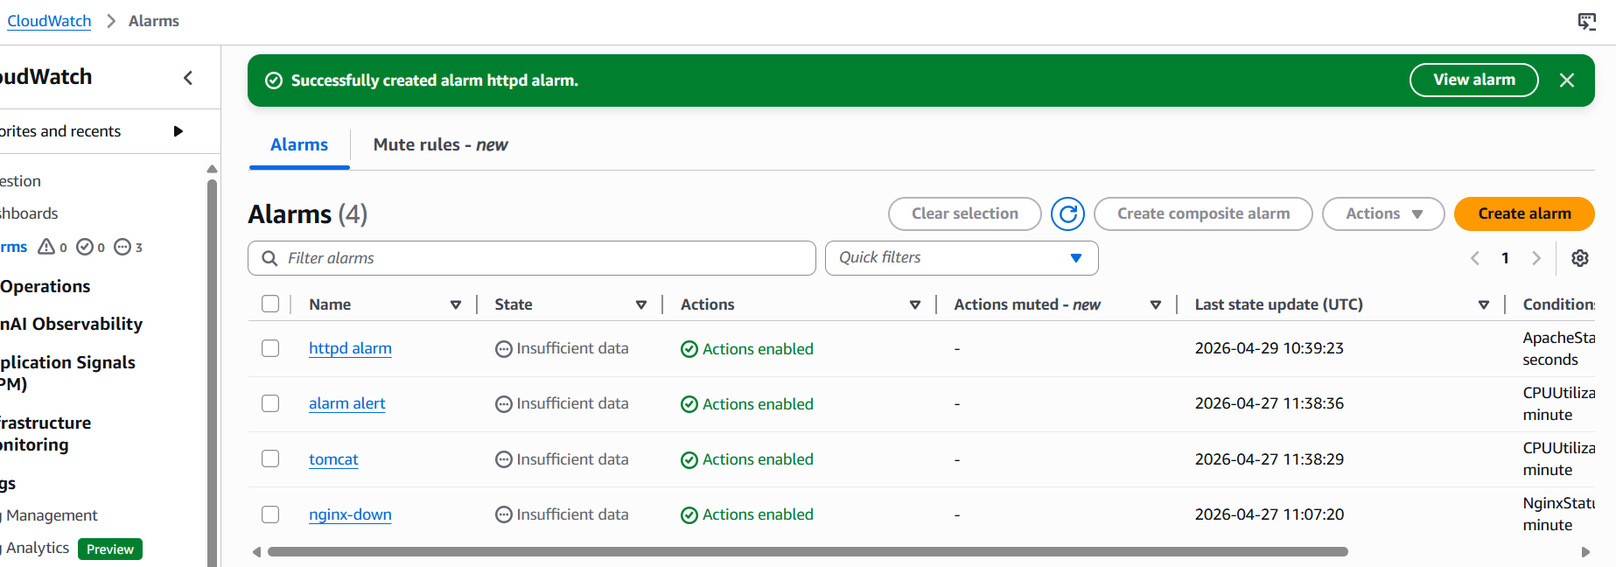
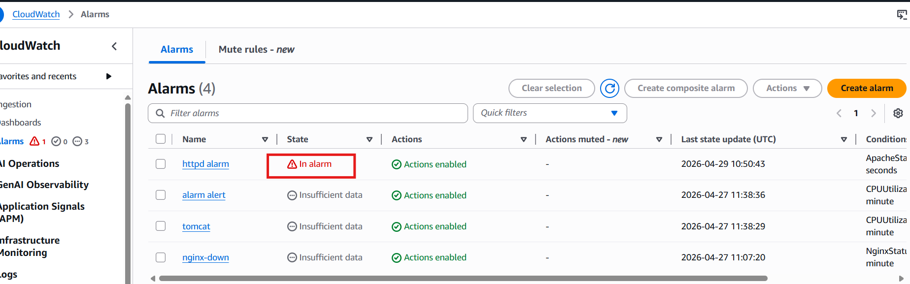
Got the email
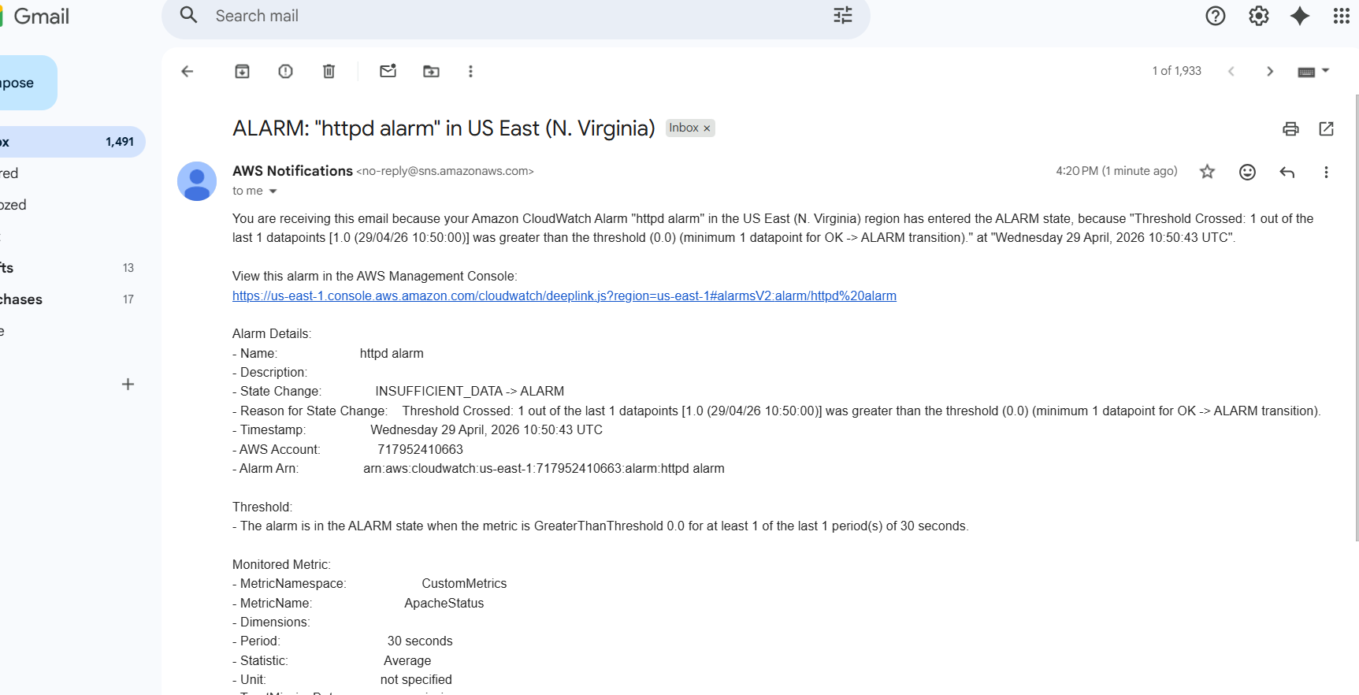

- If CPU utilization is more than 70%, then it should trigger auto scaling and launch new instance.
Go to ec2--> luunch template-->create launch template-->give name-->v1-->select ami-->select instance type-->selec key pair-->add security groups
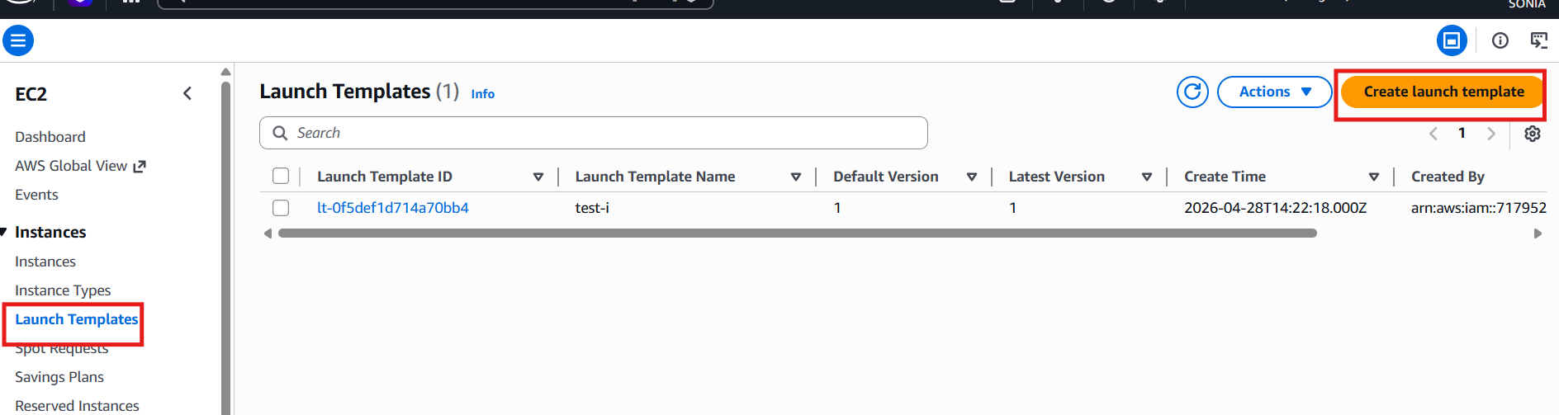
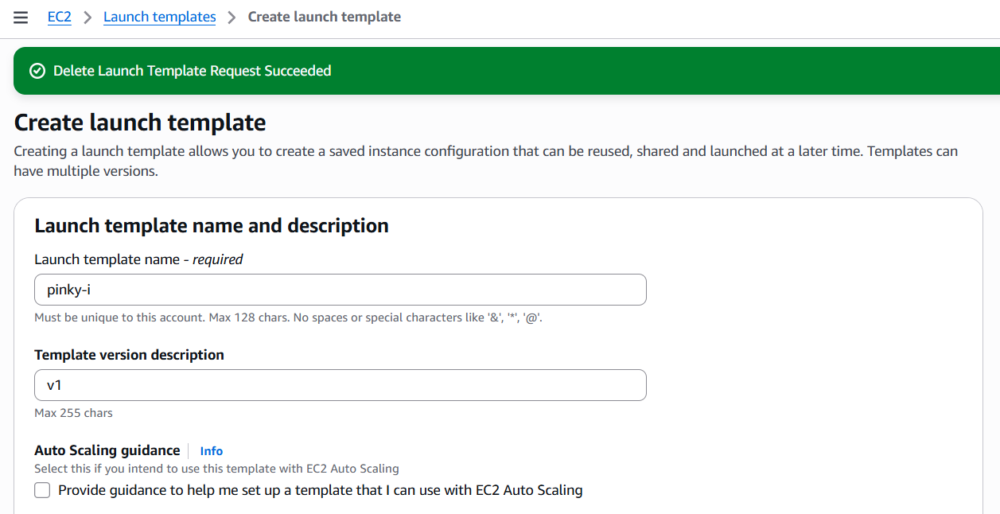
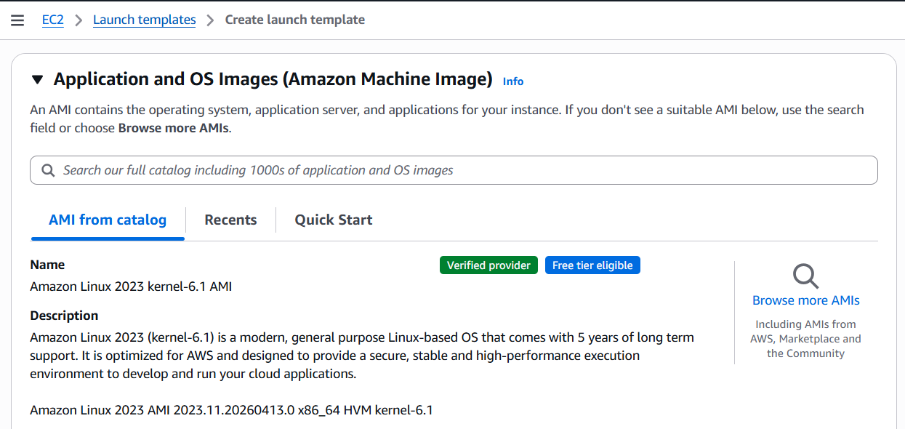
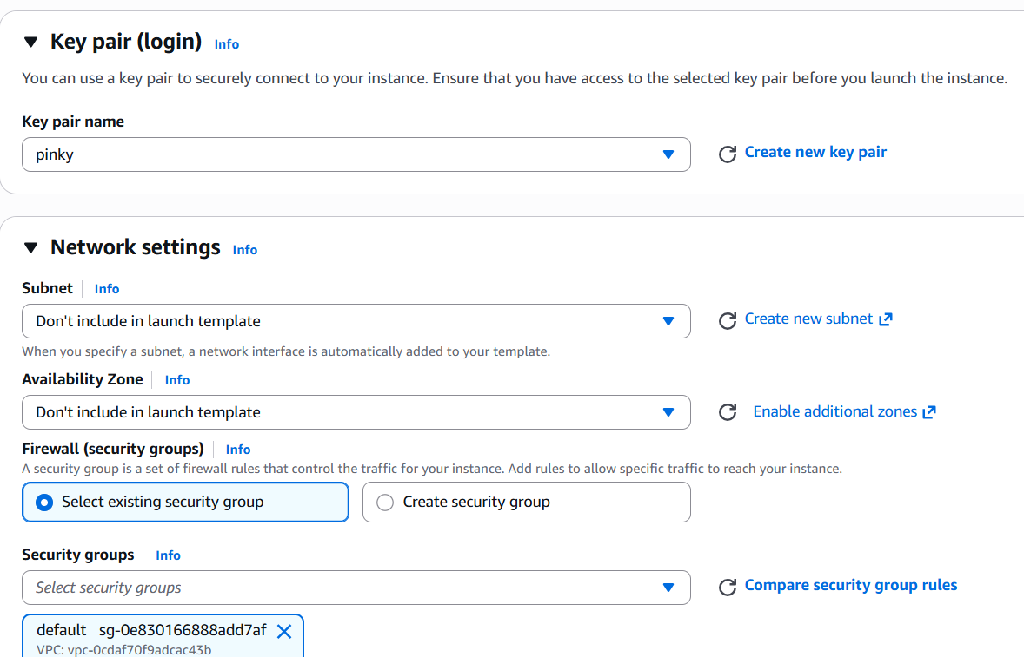
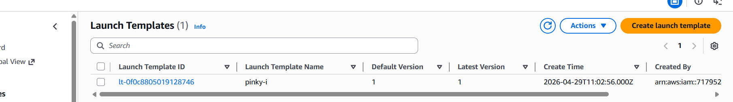
Go to auto scalling groups-->give name-->lunch tamplate name-->network settings-->

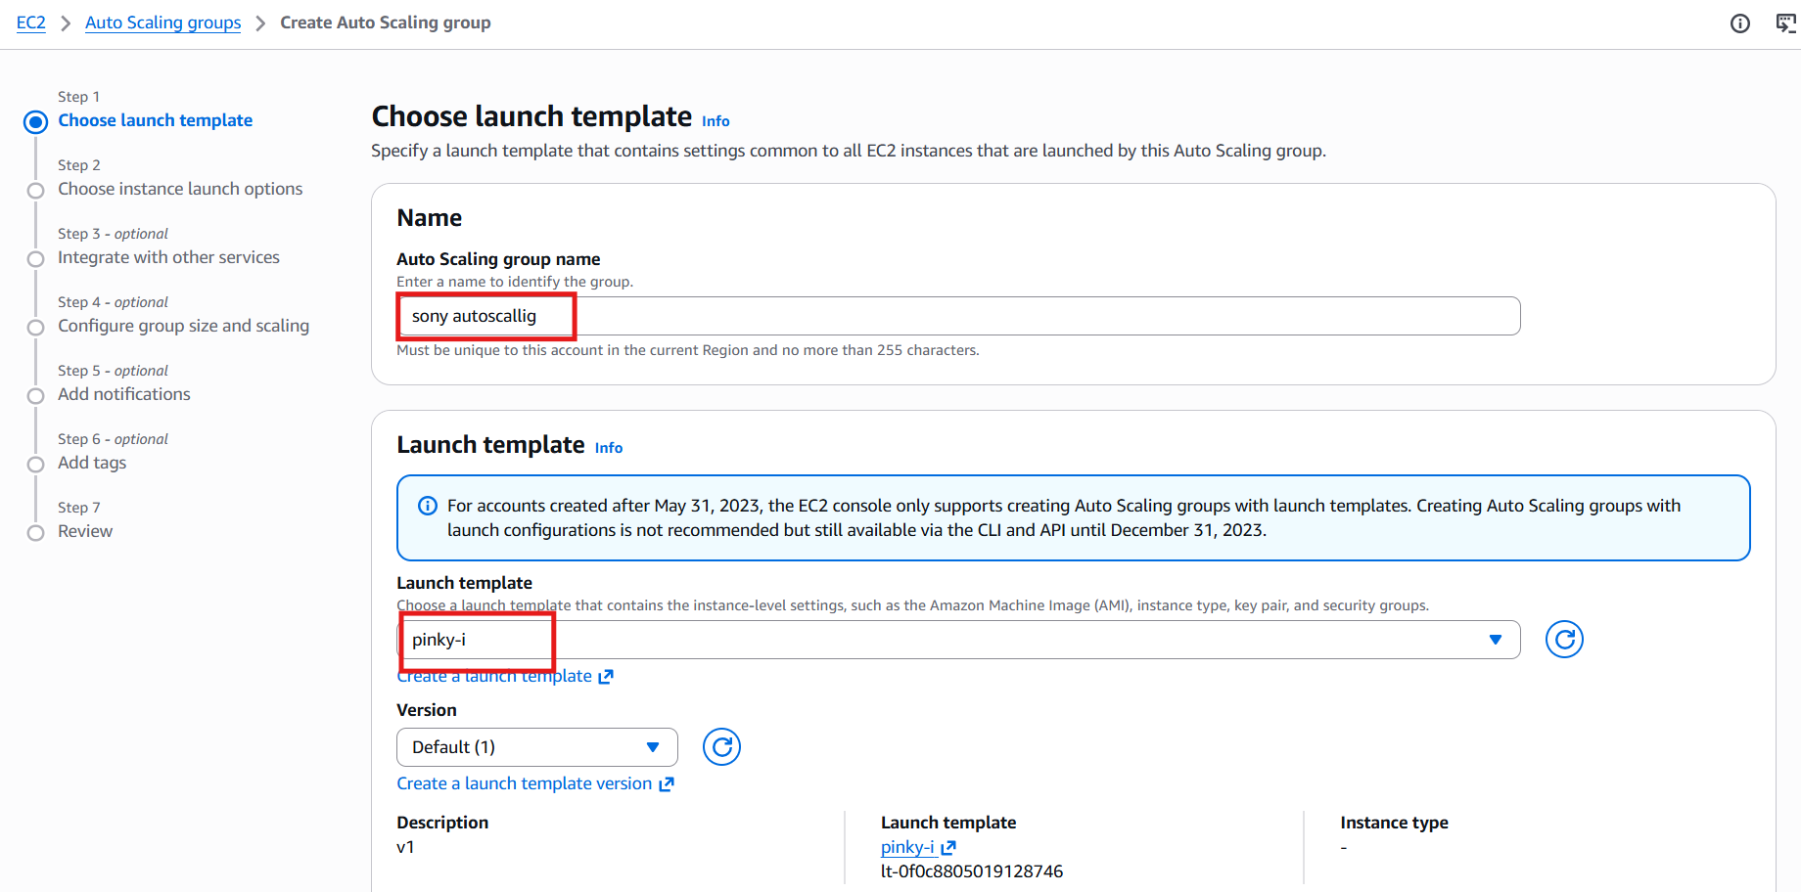
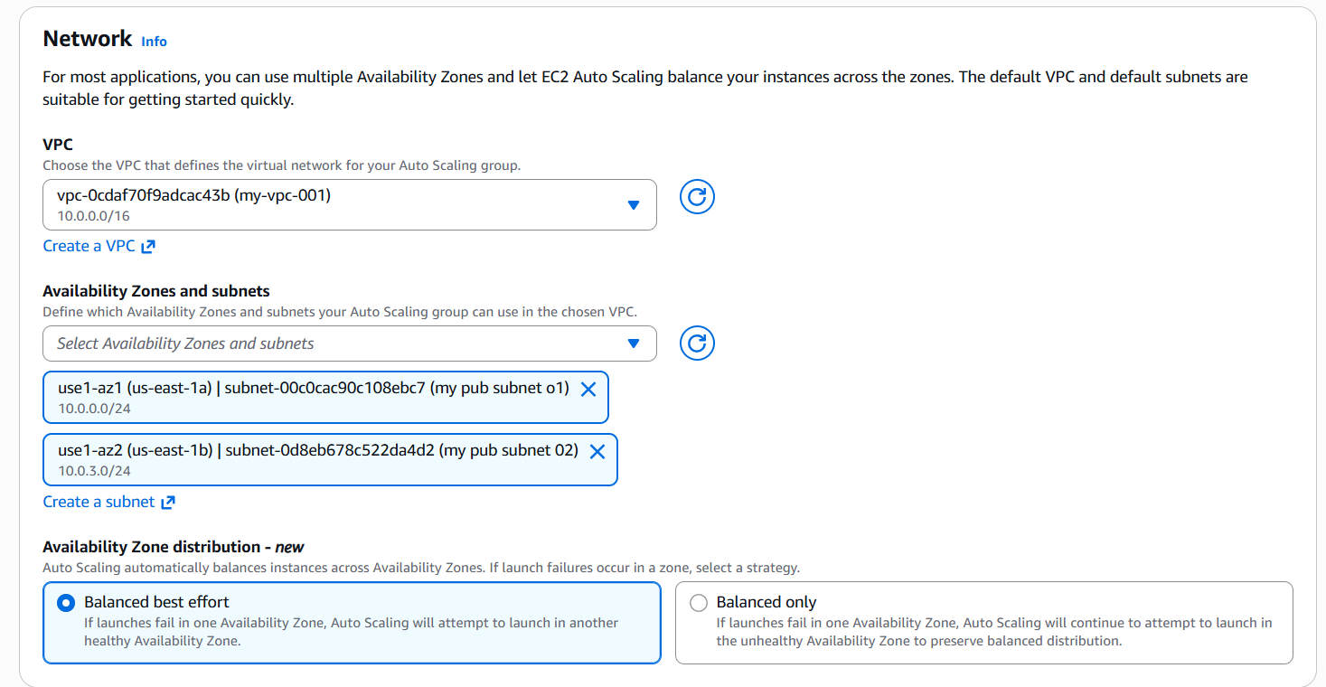
Select configure group size ans scalling-optional
